graduate COMMITTEE
curriculum PROPOSAL FORM

A. Cover page (hover over text for more instructions)

A.1. Course or program | Faculty of Arts Sciences - graduate degree Programs
Replacing
Academic Unit | Faculty of Arts and Sciences |
A.2. Proposal type | Program | revision
A.3. Originator | Joan Dagle, Associate Dean, FAS |  |  |  | Arts & Sciences
A.4. Rationale  Additional Information for new programs | All graduate degree programs in A&S will no longer require GRE scores to be submitted with applications for admission. Applicants will still have the option to submit scores if they choose to do so. This is in line with a growing trend, including regionally. Students, especially RIC undergraduates, often see the GREs as an obstacle to applying. In addition, admissions committees within Arts and Sciences place much more emphasis on the other components of students’ applications and records: transcripts, references, essay, and other materials. During the pandemic, we have waived (and continue to waive) the GRE requirement and programs have not experienced any negative impact on their ability to evaluate candidates. Many of our programs have already eliminated the GRE requirement for RIC undergraduates who apply to the MA; this change would extend that to all applicants.  This elimination of the GRE requirement also covers the Miller Analogies Test for those programs that list the MAT as an option to the GRE.  Under the Admissions Requirements for the following MA programs in A&S, the requirement to submit “An official report of scores on the Graduate Record Examination …” will be eliminated for:  Biology  History  Psychology  Justice Studies  Under the Admissions Requirements for the following MA programs in A&S, the requirement to submit “An official report of scores on the Graduate Record Examination or the Miller Analogies Test….” will be eliminated for:  Art  Mathematical Studies  Music (this is an MMEd degree)  The MA in English previously eliminated the GRE requirement.
A.5. Student impact | This will eliminate what many students perceive as an unwelcome hurdle to applying for admission to graduate programs. It should encourage more students, including our own undergraduates, to apply to MA programs.
A.6. Impact on other programs | All programs in A&S wish to adopt this change.
A.7. Resource impact | Faculty PT & FT: | None
 | Library: | None
 | Technology | None
 | Facilities: | None
A.8. Semester effective |  | A.9. Rationale if sooner than next Fall | We would like this to cover students applying during Spring 22 for admission Fall 22. We currently are continuing the “pandemic waiver” but would like to make it permanent as soon as possible.

C. Program Proposals

 | Old (for revisions only) | New/revised
C.1. Enrollments
C.2. Admission requirements | Admission Requirements: “An official report of scores on the Graduate Record Examination…”  Admission Requirements: “An official report of scores on the Graduate Record Examination or the Miller Analogies Test…” | These requirements will be deleted from the list of “Admissions Requirements” for MA programs in:  Art, p. 97  Biology, p. 99  History, p. 127  Justice Studies, p. 131  Mathematical Studies, p. 134  Music (MMEd), p. 144  Psychology, p. 154
C.3. Retention requirements
C.4. Course requirements for each program option
C.5. Credit count for each program option
C.6. Requirement for thesis, project, or comprehensive exam
C.7. Program Accreditation
C.8 Program goals
Needed for all new programs
C.9. Other changes if any

D. Signatures

D.1. Approvals: Required from department chairs, program directors, and deans from the academic unit originating the proposal.
Name | Position/affiliation | Signature | Date
Rebecca Shipe | Graduate Program Director, Art—Art Education | 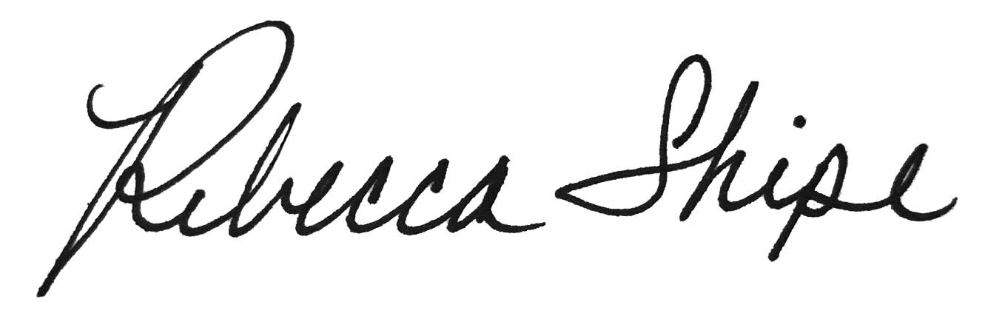 | 2/16/22
Dianne Reilly | Chair of Art Department | Dianne Reilly:  Approval via E-mail on File | 3/1/2022
Deborah Britt | Graduate Program Director, Biology | Deborah Britt:  Approval via E-mail on File | 3/1/2022
Dana Kolibachuk | Chair of Biology Department | Dana Kolibachuk:  Approval via E-mail on File | 2/16/2022
Ron Dufour | Graduate Program Director, History | Ron Dufour:  Approval via E-mail on File | 3/1/2022
Elisa Miller | Chair of History Department | Elisa Miller | 2/16/22
Lisa Humphreys | Graduate Program Director, Mathematics | Lisa Humphreys:  Approval via E-mail on File | 2/16/2022
Rebecca Sparks | Chair of Math Department | Rebecca Sparks:  Approval via E-mail on File | 3/1/2022
Rob Framzblau | Graduate Program Director, Music—Music Education | 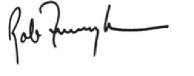 | 2.16.22
Ian Greitzer | Chair of Music, Theatre, Dance Departments | Ian Greitzer:  Approval via E-mail on File | 3/2/2022
Emily Cook | Graduate Program Director, Psychology | Emily Cook:  Approval via E-mail on File | 2/23/2022
Beth Lewis | Chair of Psychology Department | Beth Lewis:  Approval via E-mail on File | 3/1/2022
Tanni Chaudhuri | Graduate Program Director, Justice Studies (Sociology) | Tanni Chaudhuri | 02/16/22
Mikaila Arthur | Chair of Sociology Department | Mikaila Arthur:  Approval via E-mail on File | 2/16/2022
Earl Simson | Dean, Faculty of Arts & Sciences | Earl Simson | 03/01/2022

