GRADUATE COMMITTEE

CURRICULUM PROPOSAL FORM

- COVER PAGE (rover over text for more instructions- please delete red instructions)

A.1. Course or  program | M.ED. IN EARLY CHILDHOOD EDUCATION (ECE)
Academic Unit | School of Education
A.2. Proposal type | Program Revision
A.3. Originator | Mary Ellen McGuire-  Schwartz | Home department  Elementary Education
A.4. Rationale  Additional Information for new programs | The purpose of this proposal is to remove the GRE/MAT requirement from the admission requirements for the M.Ed. in ECE.  During the pandemic the GRE/MAT was waived. Applications increased with high quality candidates. There is no strong evidence to support the correlation between a high GRE/MAT score and teaching effectiveness. The M.Ed. in ECE requires teaching certification for admission except in special circumstances and with special considerations, i.e., extensive experience in early childhood teaching and/or early childhood education. Program applicants have passed various professional tests in their disciplines. The GRE/MAT tests are costly and often the cause for delaying a program admission.

A.5. Student impact | All M.Ed. in ECE program application requirements remain the same as FSEHD admission requirements with the following exception: The GRE General Exam or MAT will be waived. The M.Ed. in ECE program has specific program admission requirements including a professional goals essay, a performance-based evaluation, teacher certification in elementary education, early childhood education, or an appropriate field. (The teaching certification requirement may be waived under special circumstances and with special considerations.) An interview may be required. See Table C2 for details.
A.6. Impact on other  programs | N/A
A.7. Resource impact | Faculty PT &  FT: | none
 | Library: | none
 | Technology | none
 | Facilities: | none
A.8. Semester effective | Fall 2022 | A.9. Rationale if  sooner than next Fall
A.10 Changes to the  website | None

PROGRAM PROPOSALS

 | OLD (FOR REVISIONS ONLY) | NEW/REVISED
C.1. Enrollments
C.2. Admission requirements | Admission Requirements  M.Ed. in Early Childhood Education  Admission to the Feinstein School of Education and Human Development master's-level programs is determined by the quality of the total application. Applicants must submit the materials listed below to the associate dean of graduate studies as a measure of their potential for success in graduate-level studies. The teaching certification requirement may be waived under special circumstances and with special considerations.  - A completed application form accompanied by a fifty-dollar nonrefundable application fee.  - Official transcripts of all undergraduate and graduate records.  - A minimum cumulative grade point average (GPA) of 3.00 on a 4.00 scale in all undergraduate course work. Applicants with undergraduate GPAs less than  3.00 may be admitted to degree candidacy upon submission of other evidence of academic potential.  - A teaching certificate (for all school-related programs, except school psychology).  - An official report of scores on the Graduate Record | Admission Requirements  M.Ed. in Early Childhood Education  Admission to the Feinstein School of Education and Human Development master's-level programs is determined by the quality of the total application. Applicants must submit the materials listed below to the associate dean of graduate studies as a measure of their potential for success in graduate-level studies. The teaching certification requirement may be waived under special circumstances and with special considerations.  - A completed application form accompanied by a fifty-dollar nonrefundable application fee.  - Official transcripts of all undergraduate and graduate records.  - A minimum cumulative grade point average (GPA) of 3.00 on a 4.00 scale in all undergraduate course work. Applicants with undergraduate GPAs less than  3.00 may be admitted to degree candidacy upon submission of other evidence of academic potential.  4. A teaching certificate or early childhood teaching experience and education.

 | OLD (FOR REVISIONS ONLY) | NEW/REVISED
 | Examination or the Miller Analogies Test, except C.G.S. candidates and C.A.G.S. in mental health counseling candidates.  - Three Candidate Reference Forms accompanied by three Letters of Recommendation.  - A Professional Goals Essay.  - A Performance-Based Evaluation.  - Teacher certification in elementary education, early childhood education, or an appropriate field. (The teaching certification requirement may be waived under special circumstances and with special considerations.)  - An interview may be required. | - Three Candidate Reference Forms accompanied by three Letters of Recommendation.  - A Professional Goals Essay.  - A Performance-Based Evaluation.  - Teacher certification in elementary education, early childhood education, or an appropriate field. (The teaching certification requirement may be waived under special circumstances and with special considerations.)  - An interview may be required.
C.3. Retention requirements
C.4. Course requirements for each program option
C.5. Credit count for each
program option
C.6. Requirement for thesis, project, or comprehensive
exam
C.7. Program Accreditation
C.8 Program goals
Needed for all new programs
C.9. Other changes if any
C.10 CIP number

SIGNATURES

APPROVALS:
Required from department chairs, program directors, and deans from the academic unit originating the proposal.

NAME | POSITION/AFFILIATION | SIGNATURE | DATE
Mary Ellen McGuire-Schwartz | Program Director of M.Ed. in ECE | 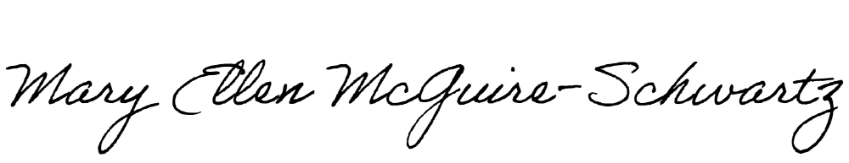 | 3/16/22
Carolyn Obel-Omia | Chair of Elementary Education | Carolyn Obel-Omia | 3/17/2022
Jeannine Dingus-Eason | Dean of Feinstein School of Education and Human Development | 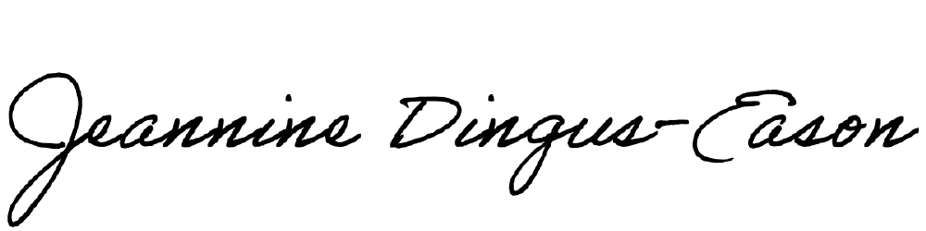 | 3/16/22

ACKNOWLEDGEMENTS:

Required from all departments (and corresponding dean) impacted by the proposal. Signature does not indicate approval. Concerns should be brought to the attention of the graduate committee
chair for discussion.

NAME | POSITION/AFFILIATION | SIGNATURE | DATE

