`

graduate COMMITTEE
curriculum PROPOSAL FORM

A. Cover page (rover over text for more instructions- please delete red instructions)

A.1. Course or program | EnGL 500 Colloquium in English: Writing, Research, and Pedagogy  Program: BA/MA in English
Academic Unit | Faculty of Arts and Sciences
A.2. Proposal type | Course: deletion  Program: revision
A.3. Originator | Anita Duneer |  |  |  | English |  |  |  | Program Director, Graduate Studies in English
A.4. Rationale  Additional Information for new programs |  | This course has never been taught. It is listed as a requirement for the BA/MA in English, and the hope was to have students take it when seniors in their undergraduate program. We are actively promoting the BA/MA, but we have not had enrollment numbers to allow faculty to offer the course. The suggested course content can be addressed in ENGL 501: Literary and Cultural Theory, which serves an introduction to studies in English for both the BA/MA and the regular MA option in either English or Creative writing. The ENGL 501 will include sufficient instruction in writing, research, and pedagogy for these students. In lieu of ENGL 500, students will take an additional 500-level English course of their choice, which will allow them to choose something specific to their interests.  ENGL 500 will be deleted from the catalog.
A.5. Student impact |  | This will allow BA/MA students to take an additional English graduate course in a topic that interests them.
A.6. Impact on other programs |  | None
A.7. Resource impact | Faculty PT & FT: |  |  | None
 | Library: |  |  | None
 | Technology |  |  | None
 | Facilities: |  |  | None
A.8. Semester effective | Fall 2022 |  | A.9. Rationale if sooner than next Fall
A.10 Changes to the website |  | English BA-to-MA Course Information: Delete ENGL 500, and have it list ENGL 501 and two electives at the 500-level.

A.10. INSTRUCTIONS FOR CATALOG COPY: This single file copy must include all relevant pages from the college catalog, and show how the catalog will be revised.
(1) Go to the “Forms and Information” on the GCC website

https://w3.ric.edu/graduate_committee/Pages/how-to-submit-a-proposal.aspx#catalog

Scroll down until you see the Word files for the current catalog.
(2) Download ALL catalog sections relevant for this proposal, including course descriptions and/or other affected programs.
(3) Place ALL relevant catalog copy into a single file. Put page breaks between sections and delete any catalog pages not relevant for this proposal.
(4) Using the track changes function, revise the catalog pages to demonstrate what the information should look like in next year’s catalog.
(5) Check the revised catalog pages against the proposal, making sure that program totals are correct when adding or deleting course credits.

C. Program Proposals

 | Old (for revisions only) | New/revised
C.1. Enrollments | 1 | 4
C.2. Admission requirements
C.3. Retention requirements
C.4. Course requirements for each program option | Undergraduate students matriculated at Rhode Island College can apply for conditional admission to the Master of Arts in English program after completing 72 credits, at least 12 of which must be in English courses taken at RIC. If conditionally admitted to the M.A. program, students begin taking graduate courses after completing 90 credits. They will take 9 credits of graduate coursework that can count toward both the B.A. and M.A. degrees: ENGL 500, ENGL 501, and one elective 500-level seminar. In addition, conditionally admitted students can take one 500-level course that will count only toward the M.A. degree. If students are in good standing upon completion of the B.A., they are fully admitted to the M.A. degree program, which could be completed in two semesters.  Admission requirements remain the same as for the M.A. degree with the following exception: a minimum G.P.A. of 3.2 in English courses. | Undergraduate students matriculated at Rhode Island College can apply for conditional admission to the Master of Arts in English program after completing 72 credits, at least 12 of which must be in English courses taken at RIC. If conditionally admitted to the M.A. program, students begin taking graduate courses after completing 90 credits. They will take 9 credits of graduate coursework that can count toward both the B.A. and M.A. degrees: ENGL 501, and two elective 500-level seminars. In addition, conditionally admitted students can take one 500-level course that will count only toward the M.A. degree. If students are in good standing upon completion of the B.A., they are fully admitted to the M.A. degree program, which could be completed in two semesters.  Admission requirements remain the same as for the M.A. degree with the following exception: a minimum G.P.A. of 3.2 in English courses.
C.5. Credit count for each program option | Allows for 9 500-level credits toward their BA and MA degrees.  The MA requires 30 credits. | Allows for 9 500-level credits toward their BA and MA degrees.  The MA requires 30 credits.
C.6. Requirement for thesis, project, or comprehensive exam
C.7. Program Accreditation
C.8 Program goals
Needed for all new programs
C.9. Other changes if any
C.10 CIP number

D. Signatures

D.1. Approvals:

Required from department chairs, program directors, and deans from the academic unit originating the proposal.

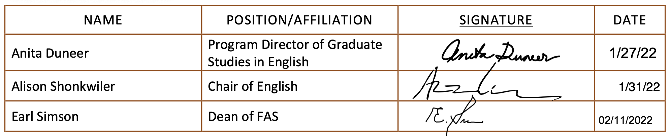

D.2. Acknowledgements:

Required from all departments (and corresponding dean) impacted by the proposal. Signature does not indicate approval. Concerns should be brought to the attention of the graduate committee chair for discussion.

Name | Position/affiliation | Signature | Date
n/a

