graduate COMMITTEE
curriculum PROPOSAL FORM

A. Cover page (hover over text for more instructions)

A.1. Course or program | Masters of nursing science (MSN) admissions procedure
Replacing | Masters of nursing science (MSN) admissions procedure
Academic Unit | School of Nursing
A.2. Proposal type | Program: MSN Admissions Procedure revision
A.3. Originator | Patricia Molloy |  | Home department |  | Nursing
A.4. Rationale  Additional Information for new programs | Revision of language in the procedure adds clarity to the current process
A.5. Student impact | Positive - provides clarity
A.6. Impact on other programs | None known
A.7. Resource impact | Faculty PT & FT: | None
 | Library: | None
 | Technology | None
 | Facilities: | None
A.8. Semester effective | Spring 2022 | A.9. Rationale if sooner than next Fall |  | Some programs have rolling admissions and some students may wish to enroll in summer courses

C. Program Proposals

 | Old (for revisions only) | New/revised
C.1. Enrollments
C.2. Admission requirements | Admission Requirements for All M.S.N. Students  1. A completed application form accompanied by a $50 nonrefundable application fee.  2. A baccalaureate degree in an upper-division nursing major from an NLNAC or CCNE accredited program.  3. Applicants with international degrees must have their transcripts evaluated for degree and grade equivalency to that of a regionally accredited institution in the United States.  4. Official transcripts of all undergraduate and graduate records.  5. Completion of a course in statistics (MATH 240 or its equivalent), with a minimum grade of C.  6. A minimum cumulative grade point average of 3.00 on a 4.00 scale in undergraduate course work.  7. An official report of scores on the Graduate Record Examination or the Millers Analogies Test.  8. An official report of scores on the Test of English as a Foreign Language from international applicants who are from countries where English is not the first language.  9. Current unrestricted licensure for the practice of nursing in Rhode Island.  10. A professional résumé.  11. Three professional references (one from the clinical area).  12. A brief letter of intent, which includes a statement of goals.  13. Proof of residency.  14. An interview may be required.  15. Under certain circumstances when an application does not meet a requirement for admission, the program may provisionally offer acceptance to an otherwise qualified candidate. Examples include but are not limited to academic concerns related to GPA below 3.0, letter of intent, CV, letters of recommendation or work experience. Under this provision, the applicant will be permitted take courses on a non-matriculated basis and must achieve a minimum B grade in three required nursing courses. Upon meeting this requirement, the program will matriculate the applicant into the MSN program. Students who are allowed take classes on a provisional, non-matriculated basis are not eligible for financial aid, graduate assistantships or scholarships.  Additional Admission Requirements for R.N. to M.S.N. Students  Students must fulfill all of the above requirements and successfully complete the R.N. to B.S.N. program, including MATH 240. When at senior standing in the B.S.N. program, students may complete NURS 501, NURS 502, NURS 503, or NURS 512 (up to 9 credits) as electives. Those completed M.S.N. courses will be waived upon entry into the M.S.N. program of study.  Additional Admission Requirement for the Adult/Gerontology Acute Care Option  One year of relevant acute care experience.  Additional Admission Requirements for Nurse Anesthesia  Due to clinical rotations at hospitals in Massachusetts, a license is required for Massachusetts. Personal interview is required. Completion of two courses in chemistry (Chem 105, 106) within the last ten years with minimum grades of C. A preferred undergraduate science GPA of 3.0. Of the three required references, one must be from a clinical supervisor. Current ACLS certification. Minimum of one year critical care experience. A complete definition of accepted critical care experience is found on the St. Joseph Hospital School of Nurse Anesthesia website: www.sjhsna.com.  Additional Admission Requirements for Nurse Anesthesia:  1. Due to clinical rotations at hospitals in Massachusetts, a license is required for Massachusetts.  2. Personal interview is required.  3. Completion of two courses (total of 8 credits) in chemistry (Chem 105, 106) within the last 10 years with minimum grades of C.  4. A preferred undergraduate science GPA of 3.0  5. Of the three required references, one must be from a clinical supervisor.  6. Current ACLS certification.  7. Minimum of 1 year of critical care experience. Complete definition of accepted critical care experience is found on the sjhsna website: www.sjhsna.com  8. Skills and abilities applicants and students must demonstrate are also on the sjhsna website: www.sjhsna.com | Admission Requirements for All M.S.N. Students  Admission to graduate study at the Rhode Island College School of Nursing is selective and determined by the quality of the total application. Applications are submitted on-line and are available for the MSN program at https://www.applyweb.com/ricg/index.ftl  Applications for the Adult Gerontology Acute Care NP option open on October 15th and the deadline for submission is February 15th. If space(s) remains in the NP option after the February 15th deadline, applications may be accepted for consideration at the discretion of the program director. Contact the MSN program director for further information.  Applications for the Adult Gerontology Acute Care CNS, Population/Public Health Nursing options, and the four graduate certificate programs [Adult/Gerontology Acute Care CNS - (Post-Masters), Adult/Gerontology Acute Care NP (Post-Masters), Healthcare Quality and Patient Safety, and Nursing Care Management] are accepted on an on-going basis, but applications must be received one month prior to the start of each semester.  Admission requirements include:  - A completed application accompanied by a $50 nonrefundable application fee. Active duty military and veterans are eligible to receive a fee waiver - contact Ellen Morais (emorais@ric.edu) for additional information.  - A Baccalaureate degree from an NLNAC or CCNE accredited program.  - Official transcripts of ALL undergraduate and graduate coursework.  - Completion of a course in statistics (MATH 240 or its equivalent) with a minimum grade of C within the last ten years.  - A minimum cumulative Grade Point Average (GPA) of 3.00 on a 4.00 scale in undergraduate course work. (Consideration will be given to students demonstrating successful completion of graduate level nursing classes earning 3.0 or greater).  - Eligibility for RN licensure in Rhode Island.  - A professional resume.  - Three professional references (at least one from a clinical supervisor).  - A brief letter of intent that demonstrates the candidate’s practice experience and reasons for pursuing graduate study. The statement should be representative of the applicant’s writing ability, be no more than 500 words, double-spaced, and written in 12-point font.  - Proof of residency is required for in-state tuition.  - An interview may be required.  Additional Requirements for International Students  Applicants with international degrees must have their transcripts evaluated for degree and grade equivalency to that of a regionally accredited institution in the United States. An official report of scores on the Test of English as a Foreign Language (TOEFL) for applicants who are from countries where English is not the first language. (For application assistance, see: https://www.ric.edu/department-directory/unity-center/international-immigrant-undocumented-dacamented-refugee-student-services and https://www.ric.edu/documents/international-graduate-students-guide).  Additional Admission Requirements for Adult/Gerontology Acute Care Students  A minimum of one year RN experience in an adult acute care setting within the last 3 years is recommended. An official report of scores on the Graduate Record Examination (GRE) or the Miller Analogies Test (MAT). To schedule a test, visit the GRE or MAT websites at: GRE - http://www.ets.org/gre and MAT -http://www.pearsonassessments.com/postsecondaryeducation/graduate_admissions/mat.html

D. Signatures

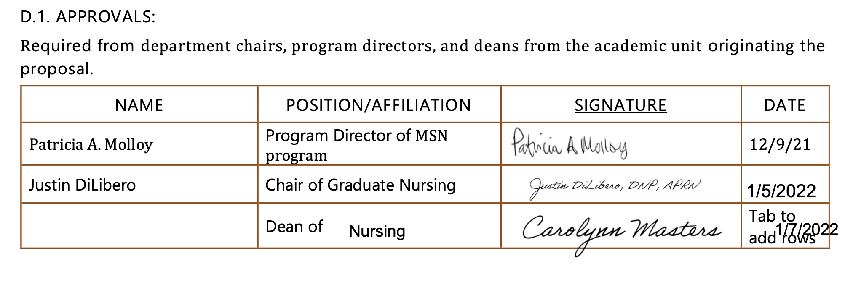

D.2. Acknowledgements:

Required from all departments (and corresponding dean) impacted by the proposal. Signature does not indicate approval. Concerns should be brought to the attention of the graduate committee chair for discussion.

Name | Position/affiliation | Signature | Date
 |  |  | Tab to add rows

