graduate COMMITTEE
curriculum PROPOSAL FORM

A. Cover page (hover over text for more instructions)

A.1. Course | NURS 704
Replacing
Academic Unit | School of Nursing
A.2. Proposal type | Course Revision
A.3. Originator | Justin DiLibero |  | Home department |  | Graduate Nursing
A.4. Rationale  Additional Information for new programs | NURS 703: Advanced Epidemiology and Biostatistics was originally intended to be an introductory course in the DNP program. The course progression has evolved so that NURS 703 is not expected to be taken later in the program. NURS 703 is currently listed as a pre-requisite to NURS 704; however, this is no longer intended.  This purpose of this proposal is to remove NURS 703 as a pre-requisite to NURS 704.
A.5. Student impact | This change will remove barriers to student progression in the program
A.6. Impact on other programs | None
A.7. Resource impact | Faculty PT & FT: | None
 | Library: | None
 | Technology | None
 | Facilities: | None
A.8. Semester effective | Spring 2022 | A.9. Rationale if sooner than next Fall

B. NEW OR REVISED COURSES

 | Old (for revisions only)  ONLY include information that is being revised, otherwise leave blank | New  Examples are provided within some of the boxes for guidance, delete just the examples that do not apply.
B.1. Course prefix and number
B.2. Cross listing number if any
B.3. Course title
B.4. Course description
B.5. Prerequisite(s) | Graduate status and NURS 703 | Graduate Status
B.6. Offered
B.7. Contact hours
B.8. Credit hours
B.9. Justify differences if any
B.10. Grading system
B.11. Instructional methods
B.11.a Delivery Method
B.12.Categories
B.13. How will student performance be evaluated?
B.14. Redundancy with, existing courses
B. 15. Other changes, if any

B.16. Course learning outcomes: List each outcome in a separate row | Professional organization standard(s), if relevant | How will each outcome be measured?
 |  | Click Tab from here to add rows

B.17. Topical outline: Please do not include a full syllabus

D. Signatures

D.1. Approvals:

Required from department chairs, program directors, and deans from the academic unit originating the proposal.
Name | Position/affiliation | Signature | Date
Justin DiLibero | Program Director of DNP Program | J. DiLIbero | 3/4/2021
Debra Servello | Chair of Graduate Department SON | 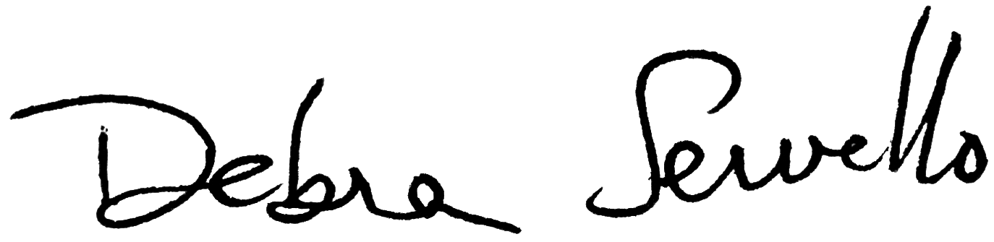 | 3/22,2021
Carolynn Masters | Dean of School of Nursing | Carolynn Masters | 3/26/2021

D.2. Acknowledgements:

Required from all departments (and corresponding dean) impacted by the proposal. Signature does not indicate approval. Concerns should be brought to the attention of the graduate committee chair for discussion.

Name | Position/affiliation | Signature | Date
 |  |  | Tab to add rows

