UNDERGRADUATE CURRICULUM COMMITTEE (UCC)
PROPOSAL FORM

Cover page scroll over blue text to see further important instructions: [if not working select “COMMents on rollover” in your Word preferences under view] please read these.
N.B. Please do not use highlight to select choices within a category but simply delete the options that do not apply to your proposal (e.g. in A.2 if this is a course revision proposal, just delete the creation and deletion options and the various program ones, so it reads “course revision”) Do not ever delete any of the numbered categories—if they do not apply leave them blank. ALL numbered categories in section (A) must be completed. If there are no resources impacted it is okay to put “none” in A. 7
A.1. Course or program | ENGL 460W Seminar in English
Replacing
A. 1b. Academic unit | Faculty of Arts and Sciences
A.2. Proposal type | Course: revision  Program: revision
A.3. Originator | Alison Shonkwiler | Home department | English
A.4. Context and Rationale  Note: Must include additional information in smart tip for all new programs | Revision of English major capstone course to merge two capstone options (ENGL 460W and ENGL 461W) into one and to better align the capstone course with program goal to prepare students for post-graduation. The ENGL 461W can still be a required elective in the Creative Writing program, but that program will now require the ENGL 460W course to complete.
A.5. Student impact  Must include to explain why this change is being made? | Students will have one capstone course option (though possibly multiple sections depending on enrollment numbers) which will allow for more flexibility in the offerings, and the revisions to its format will also better prepare all students for post-graduation.
A.6.a. Impact on other programs | This will necessitate a revision of the Creative Writing concentration to switch ENGL 460W for ENGL 461W as its capstone requirement.
A.6.b. Will this impact transfer agreements? Explain how and list what needs to be updated. | No
A.7. Resource impact | Faculty PT & FT: | None
 | Library: | None
 | Technology | None
 | Facilities: | None
A.8. Semester effective | Fall 2022 | A.9. Rationale if sooner than next Fall
A.10. INSTRUCTIONS FOR CATALOG COPY: Use the Word copy versions of the catalog sections found on the UCC Forms and Information page. Cut and paste into a single file ALL the relevant pages from the college catalog that need to be changed. Use tracked changes feature to show how the catalog will be revised as you type in the revisions. If totally new copy, indicate where it should go in the catalog. If making related proposals a single catalog copy that includes all changes is preferred. Send catalog copy as a separate single Word file along with this form.
A.11. List here (with the relevant urls), any RIC website pages that will need to be updated (to which your department does not have access) if this proposal is approved, with an explanation as to what needs to be revised:

B. NEW OR REVISED COURSES Delete section B if the proposal does not include a new or revised course. As in section A. do not highlight but simply delete suggested options not being used. Always fill in b. 1 and B. 3 for context.
 | Old (for revisions only)  ONLY include information that is being revised, otherwise leave blank. | New  Examples are provided within some of the boxes for guidance, delete just the examples that do not apply.
B.1. Course prefix and number | ENGL 460W | ENGL 460W
B.2. Cross listing number if any
B.3. Course title | Seminar in English | Seminar in English
B.4. Course description | Close analysis is made of a selected number of texts connected by theme or author(s). A research-based seminar paper or project is required. Students may repeat this course for credit with a change in topic. This is a Writing in the Discipline (WID) course. | A culminating learning experience for all English majors. Students will develop an independent research paper or project designed to demonstrate individual progress and support professional goals. This is a Writing in the Discipline WID course.
B.5. Prerequisite(s)
B.6. Offered
B.7. Contact hours
B.8. Credit hours
B.9. Justify differences if any
B.10. Grading system
B.11. Instructional methods
B.11.a Delivery Method
B.12. CATEGORIES  12. a. How to be used | Required for English major | Required for English major and the Creative Writing concentration
12 b. Is this an Honors  course? | NO | NO
12. c. General Education  N.B. Connections must include at  least 50% Standard Classroom  instruction. | NO  category: | NO  category:
12. d. Writing in the  Discipline (WID) | YES | YES
B.13. How will student performance be evaluated? |  | Attendance | Class participation | Papers | Class Work | Projects | Portfolio
B.14 Recommended class-size | 15 | 15
B.15. Redundancy statement
B. 16. Other changes, if any | This course will no longer be repeatable with a change in topic.

B.17. Course learning outcomes: List each one in a separate row | Professional Org.Standard(s), if relevant | How will each outcome be measured?
Understanding of skills acquired in the English major and transferability of those skills |  | Class work, including written self-reflection assignment
Articulation of career goals |  | Skills self-assessment assignment
Career readiness |  | Resume/CV, LinkedIn profile, portfolio
Articulation of applicability of skills acquired in the English major for professional goals |  | Capstone project and reflection

B.18. Topical outline: DO NOT INSERT WHOLE SYLLABUS, JUST A TWO-TIER TOPIC OUTLINE. Proposals that ignore this request will be returned for revision.
What skills have I acquired as an English major?
a) Self-reflection writing assignment
- Where have I been and what have I learned as an English major? Project: taking stock of coursework, projects, experiences at RIC, etc. to identify skills/knowledge learned/acquired

What are my career goals? Where am I going as I approach graduation?
a) Skills self-assessment assignment
b) Research job listing platforms and job ads
c) Meet with Career Services
- Project: What am I good at? What do I enjoy? Where do I want to go next? Why?

Do I need or want to pursue education beyond the BA?
a) Thinking about graduate school, other professional certifications, and continuing education

How do I build a professional profile?
a) Resume/CV writing
b) Profiles on professional social media platforms (LinkedIn, etc.)

How do I prove to employers that I have the skills they want?
a) Portfolio, using LinkedIn and Portfolium
b) Capstone project and reflection

How do I talk about my professional interests with a general audience?
a) Thinking about public writing for creative writing, literary analysis, and professional writing majors
b) Capstone project and reflection (cont’d)
- How do I present myself persuasively to future employers/programs, etc?
Project: Deliverables for self-presentation including possibly resume/personal webpage/linkedin profile etc.

How do I develop personal and professional values that can guide ethical decision-making?
a) What is diversity, equity, and inclusion?
b) Research how organizations articulate and implement diversity, equity, and inclusion

How do I develop a capstone project?
a) Composing a writing sample or other career-preparedness sample
b) Writing a proposal
c) Relationship of writing and research
d) Types of research inquiry
e) Types of topics/questions
f) Investigations of available research tools/methods/archives

C. Program Proposals complete only what is relevant to your proposal if this is a revision, but include the enrollment numbers for all proposals. Delete section C if the proposal is not revising, creating, deleting or suspending any progam.

 | Old (for revisions only) | New/revised
C.1. Enrollments  Must be completed. | From 2016:  English: 111 (and 46 Secondary Ed)  Creative Writing: 56 | Current:  English: 69 (and 57 Secondary Ed)  Creative Writing: 26
C.2. Admission requirements
C.3. Retention requirements
C.4. Course requirements for each program option. Show the course requirements for the whole program here. | • 460W required for BA in literature  • 461W required for CW concentration  Course Requirements for English B.A.—with Concentration in Creative Writing  Courses  ENGL 200W Reading Literature and Culture 4 F, Sp  ENGL 220W Introduction to Creative Writing 4 F, Sp  ENGL 310 Readings for Writers 4 Annually  ENGL 461W Advanced Workshop in Creative Writing 4 As needed  ONE COURSE from  ENGL 208 British Literature 4 Annually  ENGL 209 American Literature 4 Annually  ENGL 210 Children’s Literature: Interpretation and Evaluation 4 Annually  ENGL 212 Adolescent Literature: Images of Youth 4 Annually  ENGL 222W Introduction to Professional Writing 4 Annually  ENGL 230W Workplace Writing 4 F, Sp, Su  ENGL 231W Multimodal Writing 4 As needed  ENGL 232W Public and Community Writing 4 As needed  ENGL 233W Writing for the Health Professions 4 F, Sp, Su  ENGL 250 Topics Course in Writing 4 As needed  THREE COURSES from  ENGL 371W Intermediate Creative Writing, Fiction 4 F, Sp  ENGL 372W Intermediate Creative Writing, Poetry 4 F, Sp  ENGL 373W Intermediate Creative Writing, Nonfiction Prose 4 As needed  Note: ENGL 371, ENGL 372, ENGL 373: May be repeated for credit. Students must choose at least two different courses from this list. | • 460W required for literature and CW concentration  • (461W no longer required but can remain as a required elective alongside the ENGL 371W, 372W and 373W courses)  Course Requirements for English B.A.—with Concentration in Creative Writing  Courses  ENGL 200W Reading Literature and Culture 4 F, Sp  ENGL 220W Introduction to Creative Writing 4 F, Sp  ENGL 310 Readings for Writers 4 Annually  ENGL 460W Seminar in English 4 As needed  ONE COURSE from  ENGL 208 British Literature 4 Annually  ENGL 209 American Literature 4 Annually  ENGL 210 Children’s Literature: Interpretation and Evaluation 4 Annually  ENGL 212 Adolescent Literature: Images of Youth 4 Annually  ENGL 222W Introduction to Professional Writing 4 Annually  ENGL 230W Workplace Writing 4 F, Sp, Su  ENGL 231W Multimodal Writing 4 As needed  ENGL 232W Public and Community Writing 4 As needed  ENGL 233W Writing for the Health Professions 4 F, Sp, Su  ENGL 250 Topics Course in Writing 4 As needed  THREE COURSES from  ENGL 371W Intermediate Creative Writing, Fiction 4 F, Sp  ENGL 372W Intermediate Creative Writing, Poetry 4 F, Sp  ENGL 373W Intermediate Creative Writing, Nonfiction Prose 4 As needed  ENGL 461W Advanced Workshop in Creative Writing 4  Note: ENGL 371, ENGL 372, ENGL 373: May be repeated for credit. Students must choose at least two different courses from this list.
C.5. Credit count for each program option | Same
C.6. Program Accreditation (if relevant)
C.7. Other changes if any
C.8. Program goals
Needed for all new programs

D. Signatures
- Changes that affect General Education in any way MUST be approved by ALL Deans and COGE Chair.
- Changes that directly impact more than one department/program MUST have the signatures of all relevant department chairs, program directors, and their relevant dean (e.g. when creating/revising a program using courses from other departments/programs). Check UCC manual 4.2 for further guidelines on whether the signatures need to be approval or acknowledgement.
- Proposals that do not have appropriate approval signatures will not be considered.
- Type in name of person signing and their position/affiliation.
- Send electronic files of this proposal and accompanying catalog copy to curriculum@ric.edu and a printed signature copy of this whole form to the current Chair of UCC. Check UCC website for due dates.

D.1. Approvals: required from programs/departments/deans who originate the proposal. THESE may include multiple departments, e.g., for joint/interdisciplinary proposals.
Name | Position/affiliation | Signature | Date
Mark Anderson | Program Director of Creative Writing | 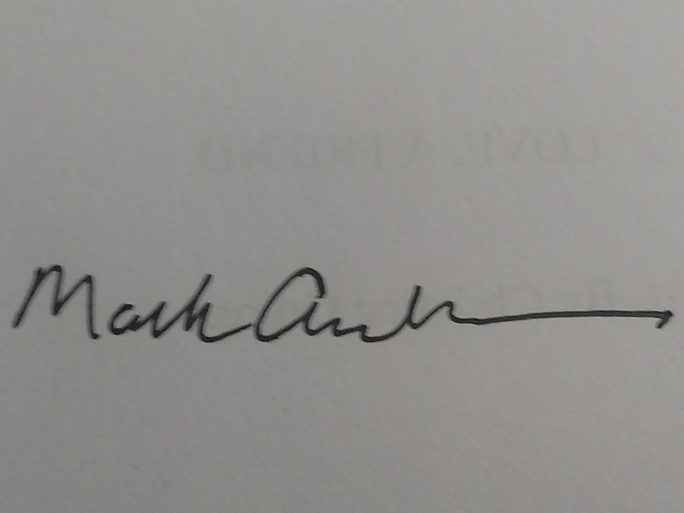 | 3/10/22
Alison Shonkwiler | Chair of English | Alison Shonkwiler | 3/11/22
Earl Simson | Dean of FAS | Earl Simson | 03/14/2022

D.2. Acknowledgements: REQUIRED from OTHER PROGRAMS/DEPARTMENTS (and their relevant deans if not already included above) that are IMPACTED BY THE PROPOSAL. SIGNATURE DOES NOT INDICATE APPROVAL, ONLY AWARENESS THAT THE PROPOSAL IS BEING SUBMITTED. CONCERNS SHOULD BE BROUGHT TO THE UCC COMMITTEE MEETING FOR DISCUSSION; all faculty are welcome to attend.
Name | Position/affiliation | Signature | Date
 |  |  | Tab to add rows

