UNDERGRADUATE CURRICULUM COMMITTEE (UCC)
PROPOSAL FORM

Cover page scroll over blue text to see further important instructions: [if not working select “COMMents on rollover” in your Word preferences under view] please read these.
N.B. Please do not use highlight to select choices within a category but simply delete the options that do not apply to your proposal (e.g. in A.2 if this is a course revision proposal, just delete the creation and deletion options and the various program ones, so it reads “course revision”) Do not ever delete any of the numbered categories—if they do not apply leave them blank. ALL numbered categories in section (A) must be completed. If there are no resources impacted it is okay to put “none” in A. 7
A.1. Course or program | ENGL 340 Studies in Poetry, Drama or prose
Replacing | ENGL 340 STUDIES IN POETRY; ENGL 342 STUDIES IN DRAMA; ENGL 343 STUDIES IN PROSE
A. 1b. Academic unit | Faculty of Arts and Sciences |
A.2. Proposal type | Course: revision and deletion
A.3. Originator | Sue Abbotson | Home department | Chair CUCI; English department
A.4. Context and Rationale  Note: Must include additional information in smart tip for all new programs | Given both a reduction in students and faculty it is impossible to offer each of these three courses on a regular basis and so we would like to combine the three into one to ensure it can be scheduled in accordance with NECHE guidelines. This will also allow for greater flexibility and possible diversity in course content moving forward. Because these courses could each be repeated for credit with a change in topic, using the first of the three prefix numbers will not be problematic for records, and all three also fulfill the same requirement in the English programs, so again, this should mean no issues with past transcripts. This is why we did not feel it necessary to select a totally new number, indeed, it is better to keep to one that is familiar.  ENGL 342 and 343 will be deleted from the catalog.
A.5. Student impact  Must include to explain why this change is being made? | This will allow for the department to be able to continue to offer upper level courses in a variety of periods and genres that reflect both student interest and faculty specialties. The alternative would be to delete all three as they cannot individually each be offered on a regular basis.
A.6. Impact on other programs | None
A.7. Resource impact | Faculty PT & FT: | None
 | Library: | None
 | Technology | None
 | Facilities: | None
A.8. Semester effective | Fall 2022 | A.9. Rationale if sooner than next Fall
A.10. INSTRUCTIONS FOR CATALOG COPY: Use the Word copy versions of the catalog sections found on the UCC Forms and Information page. Cut and paste into a single file ALL the relevant pages from the college catalog that need to be changed. Use the tracked changes feature to show how the catalog will be revised as you type in the revisions. If totally new copy, indicate where it should go in the catalog. If making related proposals a single catalog copy that includes all changes is preferred. Send catalog copy as a separate single Word file along with this form.
A.11. List here (with the relevant urls), any RIC website pages that will need to be updated (to which your department does not have access) if this proposal is approved, with an explanation as to what needs to be revised:

B. NEW OR REVISED COURSES Delete section B if the proposal does not include a new or revised course. As in section A. do not highlight but simply delete suggested options not being used. Always fill in b. 1 and B. 3 for context.
 | Old (for revisions only)  ONLY include information that is being revised, otherwise leave blank. | New  Examples are provided within some of the boxes for guidance, delete just the examples that do not apply.
B.1. Course prefix and number | ENGL 340; ENGL 342 and ENGL 343 | ENGL 340
B.2. Cross listing number if any
B.3. Course title | ENGL 340 Studies in poetry;  ENGL 342 Studies in drama;  ENGL 343 Studies in prose | Studies in Poetry, Drama or Prose
B.4. Course description | Students analyze major trends, movements and/or figures in poetry. Period, topics and approaches very with instructor. The course may be repeated for credit with a change in topic. | Students analyze major trends, movements and/or figures in poetry, drama or prose. Period, topics and approaches very with instructor. The course may be repeated for credit with a change in topic.
B.5. Prerequisite(s) | ENGL 200 or ENGL 200W, or ENGL 201 | (same)
B.6. Offered | As needed | As needed.
B.7. Contact hours
B.8. Credit hours
B.9. Justify differences if any
B.10. Grading system | Letter grade | Pass/Fail | CR/NCR
B.11. Instructional methods | | Lecture |
B.11.a Delivery Method | On campus
B.12. CATEGORIES  12. a. How to be used | |Restricted elective for major/minor | Free elective |
12 b. Is this an Honors  course? | | NO
12. c. General Education  N.B. Connections must include at  least 50% Standard Classroom  instruction. | | NO |  category:
12. d. Writing in the  Discipline (WID) | | NO
B.13. How will student performance be evaluated? | Attendance | Class participation | Exams | Presentations | Papers |  Class Work | | Quizzes |
B.14 Recommended class-size | 30
B.15. Redundancy statement
B. 16. Other changes, if any

B.17. Course learning outcomes: List each one in a separate row | Professional Org.Standard(s), if relevant | How will each outcome be measured?
Given this is not a course creation—but a combination of three courses that have all been approved in the past, it seems unncessary to supply outcomes as they have not changed—the course will continue to follow the department outcomes for 300-level lit. courses already established. |  | Click Tab from here to add rows

B.18. Topical outline: DO NOT INSERT WHOLE SYLLABUS, JUST A TWO-TIER TOPIC OUTLINE. Proposals that ignore this request will be returned for revision.
Given this is not a course creation—but a combination of three courses that have all been approved in the past, it seems unncessary to supply a topical outline—the course will be taught in a variety of ways, that will follow the outlines suggested in the previous 340, 342 or 343.

D. Signatures
- Changes that affect General Education in any way MUST be approved by ALL Deans and COGE Chair.
- Changes that directly impact more than one department/program MUST have the signatures of all relevant department chairs, program directors, and their relevant dean (e.g. when creating/revising a program using courses from other departments/programs). Check UCC manual 4.2 for further guidelines on whether the signatures need to be approval or acknowledgement.
- Proposals that do not have appropriate approval signatures will not be considered.
- Type in name of person signing and their position/affiliation.
- Send electronic files of this proposal and accompanying catalog copy to curriculum@ric.edu and a printed signature copy of this whole form to the current Chair of UCC. Check UCC website for due dates.

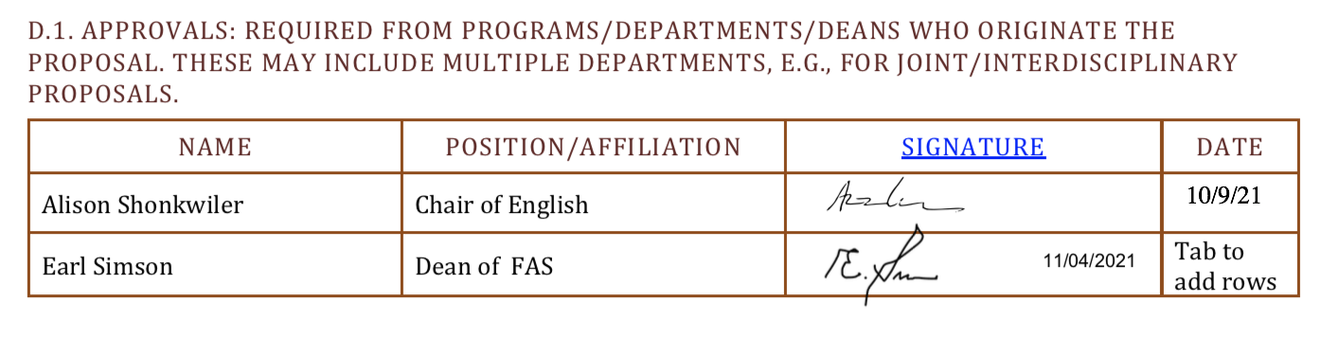

D.2. Acknowledgements: REQUIRED from OTHER PROGRAMS/DEPARTMENTS (and their relevant deans if not already included above) that are IMPACTED BY THE PROPOSAL. SIGNATURE DOES NOT INDICATE APPROVAL, ONLY AWARENESS THAT THE PROPOSAL IS BEING SUBMITTED. CONCERNS SHOULD BE BROUGHT TO THE UCC COMMITTEE MEETING FOR DISCUSSION; all faculty are welcome to attend.
Name | Position/affiliation | Signature | Date
 |  |  | Tab to add rows

