UNDERGRADUATE CURRICULUM COMMITTEE (UCC)
PROPOSAL FORM

Cover page
A.1. Course or program | HIST 117 Special Topics in History  HIST 118 TOPICS IN U.S. HISTORY TO 1877  HIST 119 TOPICS IN U.S. HISTORY FROM 1877 TO THE PRESENT
Replacing
A. 1b. Academic unit | Faculty of Arts and Sciences
A.2. Proposal type | Course: | revision |
A.3. Originator | Holly Shadoian |  | Academic Affairs
A.4. Context and Rationale  Note: Must include this additional information for all new programs | HIST 117 Special Topics in History  HIST 118 Topics in U.S. History to 1877  HIST 119 Topics in U.S. History from 1877 to the Present  These three history courses are long time offerings of the Early Enrollment Program (EEP) but are not offered on campus. They have counted as elective credit only. URI awards Gen Ed credit for all three, putting RIC at a disadvantage in terms of articulation and potential recruitment of students. The chair of the History department has agreede to allow these three history courses to count as 4-credit Gen Ed Hist courses. They will maintain their original course titles and descriptions. Prior to the history department changing the majority of their courses to 3 credits, these courses were all 4 credits each. Because they will now serve as satisfying a Gen Ed requirement, the number of credits will change back to 4.  EEP students taking any of these three courses will benefit from being able to receive Gen Ed credit from Rhode Island College.
A.5. Student impact | EEP students who attend RIC will be able to count any one of these courses as satisfying the History category of General Education
A.6. Impact on other programs | None other than Gen Ed.
A.7. Resource impact | Faculty PT & FT: | none
 | Library: | none
 | Technology | none
 | Facilities: | none
A.8. Semester effective | Fall 2021 | A.9. Rationale if sooner than next Fall

B. NEW OR REVISED COURSES Delete section B if the proposal does not include a new or revised course. As in section A. do not highlight but simply delete suggested options not being used. Always fill in b. 1 and B. 3 for context.
 | Old (for revisions only)  ONLY include information that is being revised, otherwise leave blank. | New
B.1. Course prefix and number | HIST 117  HIST 118  HIST 119 | Same
B.2. Cross listing number if any
B.3. Course title | Special Topics in History  Topics in U.S. History to 1877  Topics in U.S. History from 1877 to the Present | Same
B.4. Course description
B.5. Prerequisite(s)
B.6. Offered
B.7. Contact hours
B.8. Credit hours
B.9. Justify differences if any
B.10. Grading system
B.11. Instructional methods
B.12.Categories
B.13. Is this an Honors course?
B.14. General Education  N.B. Connections must include at least 50% Standard Classroom instruction. | NO | YES |  category: History
B.15. How will student performance be evaluated?
B.16 Recommended class-size
B.17. Redundancy statement
B. 18. Other changes, if any

D. Signatures

D.1. Approvals: required from programs/departments/deans who originate the proposal. THESE may include multiple departments, e.g., for joint/interdisciplinary proposals.
Name | Position/affiliation | Signature | Date
Earl Simson | Den, Faculty of Arts & Sciences | Earl Simson | 4/30/2021
Jeannine Dingus Eason | Dean, School of Education | Jeannine Dingus-Eason | 5/3/2021
Carolynn Masters | Dean, School of Nursing | 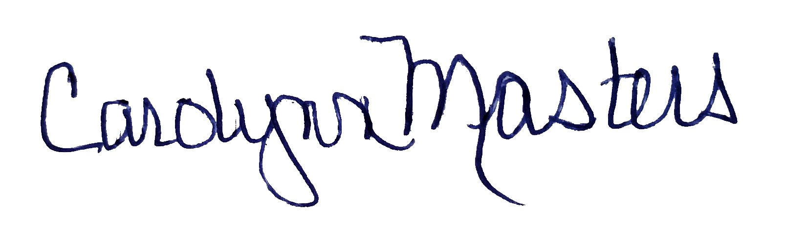 | 5/1/2021
Jayashree Nimmagadda | Interim Dean, School of Social Work | *Approved by e-mail | 4/30/2021
Alema Karim | Interim Dean, School of Business
Elisa Miller | Chair, History | *Approved by e-mail | 4/29/2021
Joseph Zornado | Chair, COGE | *approved by e-mail | 4/28/2021

D.2. Acknowledgements: REQUIRED from OTHER PROGRAMS/DEPARTMENTS (and their relevant deans if not already included above) that are IMPACTED BY THE PROPOSAL. SIGNATURE DOES NOT INDICATE APPROVAL, ONLY AWARENESS THAT THE PROPOSAL IS BEING SUBMITTED. CONCERNS SHOULD BE BROUGHT TO THE UCC COMMITTEE MEETING FOR DISCUSSION; all faculty are welcome to attend.
Name | Position/affiliation | Signature | Date
 |  |  | Tab to add rows

