UNDERGRADUATE CURRICULUM COMMITTEE (UCC)
PROPOSAL FORM

Cover page

A.1. Course or program | ENGL 118 Introduction to the literary experience
Replacing
A. 1b. Academic unit | Faculty of Arts and Sciences
A.2. Proposal type | Course: | revision |
A.3. Originator | Holly Shadoian | Home department | Academic Affairs
A.4. Context and Rationale  Note: Must include this additional information for all new programs | ENGL 118 Introduction to the Literary Experience is a long time offering of the Early Enrollment Program (EEP) but is not offered on campus. It has counted as elective credit only. URI awards Gen Ed credit for the course, putting RIC at a disadvantage in terms of articulation and potential recruitment of students.  The chair of the English department is allowing ENGL 118 to count as a Gen Ed Lit course. ENGL 118 will maintain its course description and title.  EEP students taking ENGL 118 will benefit from being able to receive Gen Ed credit from Rhode Island College for the course.
A.5. Student impact | EEP students who attend RIC will be able to count this course as satisfying the Literature category of General Education
A.6. Impact on other programs | None—other than Gen Ed.
A.7. Resource impact | Faculty PT & FT: | none
 | Library: | none
 | Technology | none
 | Facilities: | none
A.8. Semester effective | Fall 2021 | A.9. Rationale if sooner than next Fall
B. NEW OR REVISED COURSES
 | Old (for revisions only)  ONLY include information that is being revised, otherwise leave blank. | New  Examples are provided within some of the boxes for guidance, delete just the examples that do not apply.
B.1. Course prefix and number | ENGL 118 | Same
B.2. Cross listing number if any
B.3. Course title | Introduction to the Literary Experience | Same
B.4. Course description |  | Same
B.5. Prerequisite(s)
B.6. Offered
B.7. Contact hours
B.8. Credit hours
B.9. Justify differences if any
B.10. Grading system
B.11. Instructional methods
B.11.a Delivery Method
B.12.Categories
B.13. Is this an Honors course?
B.14. General Education  N.B. Connections must include at least 50% Standard Classroom instruction. | NO | YES |  category: Literature
B.15. How will student performance be evaluated?
B.16 Recommended class-size
B.17. Redundancy statement
B. 18. Other changes, if any

D. Signatures

D.1. Approvals: required from programs/departments/deans who originate the proposal. THESE may include multiple departments, e.g., for joint/interdisciplinary proposals.
Name | Position/affiliation | Signature | Date
Earl Simson | Dean, Faculty of Arts & Sciences | Earl Simson | 4/30/2021
Jeannine Dingus Eason | Dean, School of Education | Jeannine Dingus-Eason | 5/3/2021
Carolynn Masters | Dean, School of Nursing | 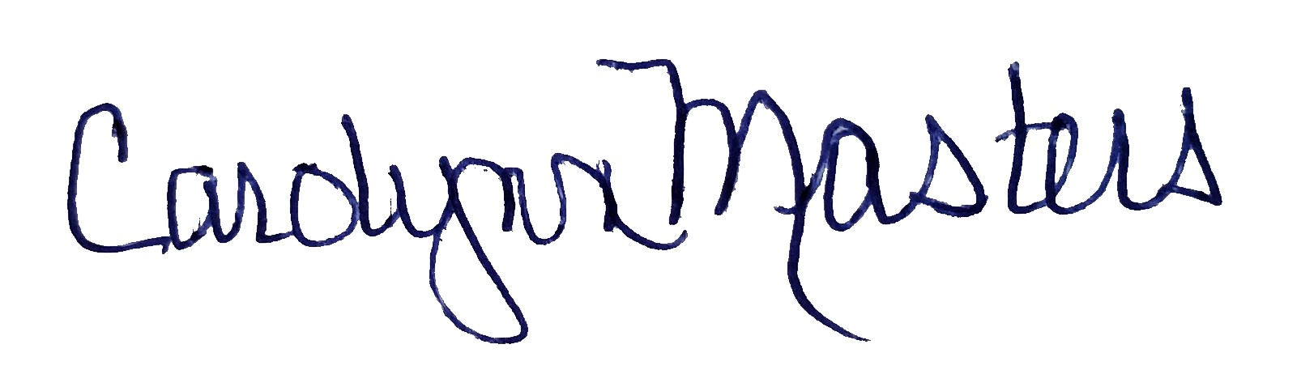 | 5/1/2021
Jayashree Nimmagadda | Interim Dean, School of Social Work | *Approved by e-mail | 4/30/2021
Alema Karim | Interim Dean, School of Business | *approved by e-mail | 4/30/2021
Alison Shonkweiler | Chair, English | *approved by e-mail | 4/30/2021
Joseph Zornado | Chair, COGE | *approved by e-mail | 4/28/2021

D.2. Acknowledgements: REQUIRED from OTHER PROGRAMS/DEPARTMENTS (and their relevant deans if not already included above) that are IMPACTED BY THE PROPOSAL. SIGNATURE DOES NOT INDICATE APPROVAL, ONLY AWARENESS THAT THE PROPOSAL IS BEING SUBMITTED. CONCERNS SHOULD BE BROUGHT TO THE UCC COMMITTEE MEETING FOR DISCUSSION; all faculty are welcome to attend.
Name | Position/affiliation | Signature | Date
 |  |  | Tab to add rows

