UNDERGRADUATE CURRICULUM COMMITTEE (UCC)
PROPOSAL FORM

Cover page

A.1. Course or program | ART 201 introduction to Visual arts
Replacing | ART 201 (existed in ric catalog until 2014)
A. 1b. Academic unit | Faculty of Arts and Sciences
A.2. Proposal type | Course: creation | revision |
A.3. Originator | Holly Shadoian, Vice Provost |  | Academic Affairs
A.4. Context and Rationale  Note: Must include this additional information for all new programs | ART 201 Introduction to Visual Arts existed as a regular 4cr RIC Gen Ed Arts course until 2014. During that time, ART 201 was an EEP offering and still continues to be offered. However, it is no longer listed in the college catalog. Therefore, this proposal requests the “return” of ART 201 as a catalog-listed course with the original course description and a minor change to the course numbering, but also convert it to become a General Education course for the Arts category.  EEP students taking ART 201 will benefit from being able to receive Gen Ed credit for the course as they did when it was offered on campus.
A.5. Student impact | EEP students who attend RIC will be able to count this course as satisfying the Arts category of General Education
A.6. Impact on other programs | None—other than Gen Ed.
A.7. Resource impact | Faculty PT & FT: | NONE
 | Library: | None
 | Technology | None
 | Facilities: | None
A.8. Semester effective | Fall 2021 | A.9. Rationale if sooner than next Fall
A.10. INSTRUCTIONS FOR CATALOG COPY: This single file copy must include ALL relevant pages from the college catalog, and show how the catalog will be revised. (1) Go to the “Forms and Information” page on the UCC website. Scroll down until you see the Word files for the current catalog. (2) Download ALL catalog sections relevant for this proposal, including course descriptions and/or other affected programs. (3) Place ALL relevant catalog copy into a single file. Put page breaks between sections and delete any catalog pages not relevant for this proposal. (4) Using the track changes function, revise the catalog pages to demonstrate what the information should look like in next year’s catalog. (5) Check the revised catalog pages against the proposal form, especially making sure that program totals are correct if adding/deleting course credits. If new copy, indicate where it should go in the catalog. If making related proposals a single catalog copy that includes all is preferred. Send catalog copy as a separate single Word file along with this form.
B. NEW OR REVISED COURSES Delete section B if the proposal does not include a new or revised course. As in section A. do not highlight but simply delete suggested options not being used. Always fill in b. 1 and B. 3 for context.
B.1. Course prefix and number | ART 201 | ART 201
B.2. Cross listing number if any
B.3. Course title | Introduction to Visual Arts | same
B.4. Course description | Introduction to art-making, art vocabulary, and art history. Students work in a studio environment, producing and critiquing works while studying fine arts within the context of history and society. For non-art majors only. Studio and lecture. | same
B.5. Prerequisite(s) |  | None
B.6. Offered | Fall and Spring | As needed.
B.7. Contact hours | 4 | 4
B.8. Credit hours | 4 | 4
B.9. Justify differences if any
B.10. Grading system |  | Letter grade
B.11. Instructional methods |  | | Lecture | Studio |
B.11.a Delivery Method |  | In high schools with RIC-EEP Faculty Liaison approved EEP Instructors
B.12.Categories
B.13. Is this an Honors course? |  | NO
B.14. General Education  N.B. Connections must include at least 50% Standard Classroom instruction. |  | YES |  category: Gen Ed Arts
B.15. How will student performance be evaluated?
B.16 Recommended class-size |  | 20-30 (studio)
B.17. Redundancy statement
B. 18. Other changes, if any

B.19. Course learning outcomes: |  | How will each outcome be measured?
Students will develop their artwork through an investigation of a variety of traditional and contemporary methods and procedures. |  | Culminating presentation of a student portfolio with a minimum of 8 works
Students will engage in aesthetic analyses of art styles and history in order to further develop  their own individual work. |  | Required readings and quizzes, museum visits, reflections, class presentations  Required sketchbook of ideas that chronicles students’ artistic process/problem solving  strategies from conception to actualization.
Students will develop oral and written communication skills |  | -Be required to critique each other‘s work upon completion and participate in conceptual discussions.  -Create an essay outlining their conceptual and technical goals as well as highlighting artists throughout history that have inspired their process  - Create oral presentation both about their own work as well as established artists.

B.20. Topical outline:
● Sphere Manipulation- Idea Development
○ Using advanced idea development techniques and design processes students will turn an
ordinary sphere into a truly unique work of art.
● Still Life
○ The students will participate in creating personal still life arrangements in order to create
observational drawings with a strong focus on composition.
● Playing with Scale
○ While looking to contemporary artists for inspiration students will work with the idea of
proportions reversal as they wither shrink or enlarge everyday objects as the focus of
original works of art.
● Architectural Study
○ Students will study the work of three architects and create unique works of art that
highlight design, theory, and style of their chosen architects.
● Illustration Challenge
○ Using “Little Red Riding Hood” as their inspiration students will create original
illustrations, book covers, or unique ending to this familiar story.
● Independent Endeavors
○ Students will have a number of opportunities to choose a project that helps to deepen the
exploration of their own style, fulfill college portfolio expectations, or expand on their
current knowledge of materials and techniques.
● Social Commentary
○ After completing significant research, the students will create a unique composition that
demonstrates a clear point of view about a current political or social issue.
● Self Portrait
○ The students will create a unique self-portrait that aims to elevate the portrait from merely
the likeness of the artist to a true representation of their personality and style.
● Systems and Structures
○ A focus on contemporary art as well as the unique structures of both natural and man
made systems will lead the students to create an original composition.
● Concentration Proposal and Prototype
○ Students will write an essay and create a work of art that will act as the proposal and
jumping off point for their second semester investigation.

D. Signatures

D.1. Approvals: required from programs/departments/deans who originate the proposal. THESE may include multiple departments, e.g., for joint/interdisciplinary proposals.
Name | Position/affiliation | Signature | Date
Earl Simson | Dean, Faculty of Arts & Sciences | Earl Simson | 4/30/2021
Jeannine Dingus Eason | Dean, School of Education | Jeannine Dingus-Eason | 5/3/2021
Carolynn Masters | Dean of School of Nursing | 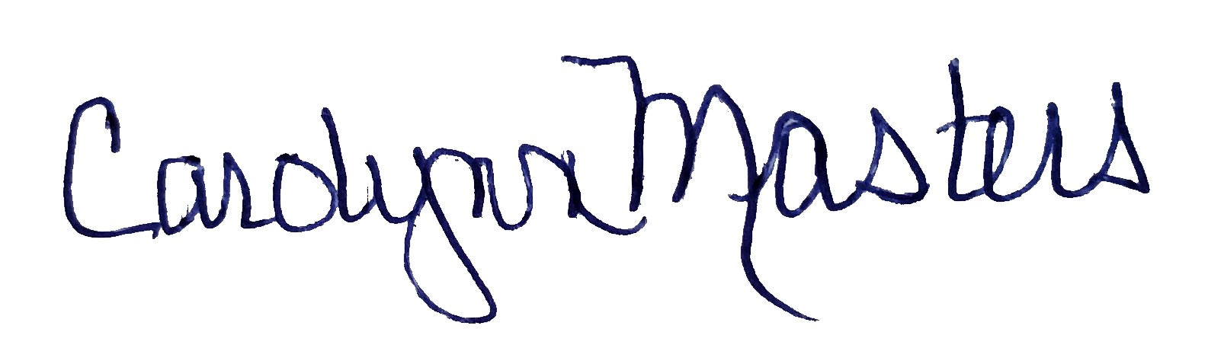 | 5/1/2021
Jayashree Nimmagadda | Interim Dean, School of Social Work | *Approved by e-mail | 4/30/2021
Alema Karim | Interim Dean, School of Business | *Approved by e-mail | 4/30/2021
Douglas Bosch | Chair, Art | *Approved by e-mail | 4/29/2021
Joseph Zornado | Chair, COGE | *Approved by e-mail | 4/28/2021

D.2. Acknowledgements: REQUIRED from OTHER PROGRAMS/DEPARTMENTS (and their relevant deans if not already included above) that are IMPACTED BY THE PROPOSAL. SIGNATURE DOES NOT INDICATE APPROVAL, ONLY AWARENESS THAT THE PROPOSAL IS BEING SUBMITTED. CONCERNS SHOULD BE BROUGHT TO THE UCC COMMITTEE MEETING FOR DISCUSSION; all faculty are welcome to attend.
Name | Position/affiliation | Signature | Date
 |  |  | Tab to add rows

