UNDERGRADUATE CURRICULUM COMMITTEE (UCC)
PROPOSAL FORM

Cover page scroll over blue text to see further important instructions: [if not working select “COMMents on rollover” in your Word preferences under view] please read these.
N.B. Please do not use highlight to select choices within a category but simply delete the options that do not apply to your proposal (e.g. in A.2 if this is a course revision proposal, just delete the creation and deletion options and the various program ones, so it reads “course revision”) Do not ever delete any of the numbered categories—if they do not apply leave them blank. ALL numbered categories in section (A) must be completed. If there are no resources impacted it is okay to put “none” in A. 7
A.1. Course or program | Hist 267 Personal Memories of the World Wars
Replacing | HIST 267 Europe and Beyond: Historical Reminiscences
A. 1b. Academic unit | Faculty of Arts and Sciences
A.2. Proposal type | Course: revision
A.3. Originator | Joanne Schneider | Home department | History
A.4. Context and Rationale  Note: Must include this additional information for all new programs | Rename and update the description of an existing course.  Currently “Europe and Beyond: Historical Reminiscences” does not seem to explain it well. Proposal to rename the course: “Personal Memories of World Wars”  Whereas the original time frame was to have been late 19th and 20th centuries finding appropriate memoirs in print proved difficult. There is never a shortage of memoirs or fiction from the two world wars, whereas those for example about Imperialism are harder to find. Also, there is no shortage of historical films related to these war memoirs, which can serve as additional material to analyze—preserving another aspect of the interdisciplinary nature of the course.  Also, by taking away the geographical notation, it leaves open choices from non-European writers as well.
A.5. Student impact | This will make it clearer to students what kind of content the course will cover, and allow for more engaging materials to be included.
A.6. Impact on other programs | none
A.7. Resource impact | Faculty PT & FT: | None, as original proposing professor would be teaching it.
 | Library: | None
 | Technology | None
 | Facilities: | None
A.8. Semester effective | Fall 2021 | A.9. Rationale if sooner than next Fall
A.10. INSTRUCTIONS FOR CATALOG COPY: This single file copy must include ALL relevant pages from the college catalog, and show how the catalog will be revised. (1) Go to the “Forms and Information” page on the UCC website. Scroll down until you see the Word files for the current catalog. (2) Download ALL catalog sections relevant for this proposal, including course descriptions and/or other affected programs. (3) Place ALL relevant catalog copy into a single file. Put page breaks between sections and delete any catalog pages not relevant for this proposal. (4) Using the track changes function, revise the catalog pages to demonstrate what the information should look like in next year’s catalog. (5) Check the revised catalog pages against the proposal form, especially making sure that program totals are correct if adding/deleting course credits. If new copy, indicate where it should go in the catalog. If making related proposals a single catalog copy that includes all is preferred. Send catalog copy as a separate single Word file along with this form.
B. NEW OR REVISED COURSES Delete section B if the proposal does not include a new or revised course. As in section A. do not highlight but simply delete suggested options not being used. Always fill in b. 1 and B. 3 for context.
 | Old (for revisions only)  ONLY include information that is being revised, otherwise leave blank. | New  Examples are provided within some of the boxes for guidance, delete just the examples that do not apply.
B.1. Course prefix and number | HIST 267
B.2. Cross listing number if any
B.3. Course title | Europe and Beyond: Historical Reminiscences | Personal Memories of the World Wars
B.4. Course description | An interdisciplinary examination of historical events since 1700 (sic) –supposed to have been 1900 – through the lens of men’s and women’s memoirs, autobiographies, fiction, and film. | Students examine personal experiences of living, serving, or suffering in the World Wars, by analyzing memoirs, fiction, and films. They compare how gender, race, ethnicity, and class influence war memories.
B.5. Prerequisite(s)
B.6. Offered
B.7. Contact hours
B.8. Credit hours
B.9. Justify differences if any
B.10. Grading system | Letter grade
B.11. Instructional methods
B.11.a Delivery Method
B.12.Categories | Gen Ed Connections | Free elective | Gen Ed Connections | Free elective
B.13. Is this an Honors course? | NO | NO
B.14. General Education  N.B. Connections must include at least 50% Standard Classroom instruction. | YES  Category: Connections | YES  category: Connections
B.15. How will student performance be evaluated?
B.16 Recommended class-size
B.17. Redundancy statement
B. 18. Other changes, if any

B.19. Course learning outcomes: List each one in a separate row | Professional Org.Standard(s), if relevant | How will each outcome be measured?
Same as original course proposal. |  | Click Tab from here to add rows

B.20. Topical outline: DO NOT INSERT WHOLE SYLLABUS, JUST A TWO-TIER TOPIC OUTLINE. Proposals that ignore this request will be returned for revision.

D. Signatures
- Changes that affect General Education in any way MUST be approved by ALL Deans and COGE Chair.
- Changes that directly impact more than one department/program MUST have the signatures of all relevant department chairs, program directors, and their relevant dean (e.g. when creating/revising a program using courses from other departments/programs). Check UCC manual 4.2 for further guidelines on whether the signatures need to be approval or acknowledgement.
- Proposals that do not have appropriate approval signatures will not be considered.
- Type in name of person signing and their position/affiliation.
- Send electronic files of this proposal and accompanying catalog copy to curriculum@ric.edu and a printed signature copy of this whole form to the current Chair of UCC. Check UCC website for due dates.

D.1. Approvals: required from programs/departments/deans who originate the proposal. THESE may include multiple departments, e.g., for joint/interdisciplinary proposals.
Name | Position/affiliation | Signature | Date
Joe Zornado | Chair of COGE | Joseph Zornado | 3/31/21
Elisa Miller | Chair of History | *approved by e-mail | 3/31/21
Earl Simson | Dean of FAS | Earl Simson | 4/8/2021
Jayashree Nimmagadda | Interim Dean, School of Social Work |  | 4/13/2021
Alema Karim | Interim Dean, School of Business | Alema Karim | 4/14/2021
Jeannine Dingus Eason | Dean, FSEHD | Jeannine Dingus-Eason | 4/20/2021
Carolynn Masters | Dean, School of Nursing | 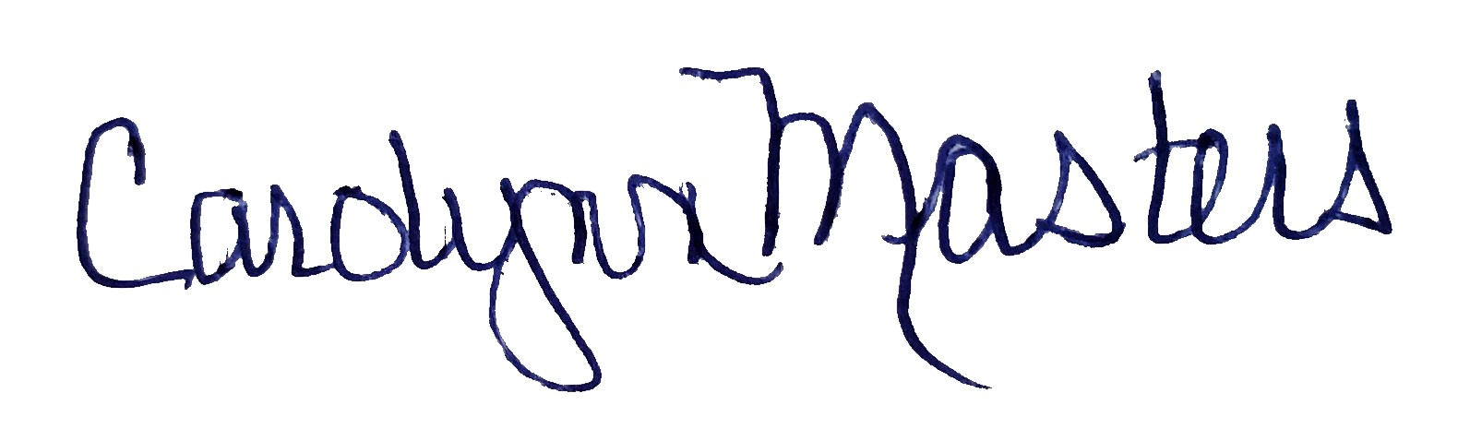 | 4/21/2021

D.2. Acknowledgements: REQUIRED from OTHER PROGRAMS/DEPARTMENTS (and their relevant deans if not already included above) that are IMPACTED BY THE PROPOSAL. SIGNATURE DOES NOT INDICATE APPROVAL, ONLY AWARENESS THAT THE PROPOSAL IS BEING SUBMITTED. CONCERNS SHOULD BE BROUGHT TO THE UCC COMMITTEE MEETING FOR DISCUSSION; all faculty are welcome to attend.
Name | Position/affiliation | Signature | Date
 |  |  | Tab to add rows

