UNDERGRADUATE CURRICULUM COMMITTEE (UCC)
PROPOSAL FORM

Cover page scroll over blue text to see further important instructions: [if not working select “COMMents on rollover” in your Word preferences under view] please read these.
N.B. Please do not use highlight to select choices within a category but simply delete the options that do not apply to your proposal (e.g. in A.2 if this is a course revision proposal, just delete the creation and deletion options and the various program ones, so it reads “course revision”) Do not ever delete any of the numbered categories—if they do not apply leave them blank. ALL numbered categories in section (A) must be completed. If there are no resources impacted it is okay to put “none” in A. 7
A.1. Course or program | anth 206 Oral traditions  anth 214 indigenous cultures in the amazonian environment  anth 325 cultures and environments in south american  anth 424 north american indians
Replacing
A. 1b. Academic unit | Faculty of Arts and Sciences
A.2. Proposal type | Course: deletion
A.3. Originator | Praveena Gullapalli | Home department | Anthropology
A.4. Context and Rationale  Note: Must include this additional information for all new programs | This is a proposal to delete courses that will no longer be offered because the faculty who taught them have retired. The courses do not intersect with areas of expertise represented by current faculty in the department.
A.5. Student impact | These topics will no longer be available to students; however other topical courses have been developed by current faculty. Deleting these courses from the catalog will more accurately represent the possible departmental course offerings to students.
A.6. Impact on other programs | Environmental Studies; Global Studies: INGOS; Modern Languages (recent Latin American Studies revision has already deleted Anth 325 as an option)
A.7. Resource impact | Faculty PT & FT: | None
 | Library: | None
 | Technology | None
 | Facilities: | None
A.8. Semester effective | Fall 2021 | A.9. Rationale if sooner than next Fall
A.10. INSTRUCTIONS FOR CATALOG COPY: This single file copy must include ALL relevant pages from the college catalog, and show how the catalog will be revised. (1) Go to the “Forms and Information” page on the UCC website. Scroll down until you see the Word files for the current catalog. (2) Download ALL catalog sections relevant for this proposal, including course descriptions and/or other affected programs. (3) Place ALL relevant catalog copy into a single file. Put page breaks between sections and delete any catalog pages not relevant for this proposal. (4) Using the track changes function, revise the catalog pages to demonstrate what the information should look like in next year’s catalog. (5) Check the revised catalog pages against the proposal form, especially making sure that program totals are correct if adding/deleting course credits. If new copy, indicate where it should go in the catalog. If making related proposals a single catalog copy that includes all is preferred. Send catalog copy as a separate single Word file along with this form.

D. Signatures
- Changes that affect General Education in any way MUST be approved by ALL Deans and COGE Chair.
- Changes that directly impact more than one department/program MUST have the signatures of all relevant department chairs, program directors, and their relevant dean (e.g. when creating/revising a program using courses from other departments/programs). Check UCC manual 4.2 for further guidelines on whether the signatures need to be approval or acknowledgement.
- Proposals that do not have appropriate approval signatures will not be considered.
- Type in name of person signing and their position/affiliation.
- Send electronic files of this proposal and accompanying catalog copy to curriculum@ric.edu and a printed signature copy of this whole form to the current Chair of UCC. Check UCC website for due dates.

D.1. Approvals: required from programs/departments/deans who originate the proposal. THESE may include multiple departments, e.g., for joint/interdisciplinary proposals.
Name | Position/affiliation | Signature | Date
Praveena Gullapalli | Chair of Anthropology | 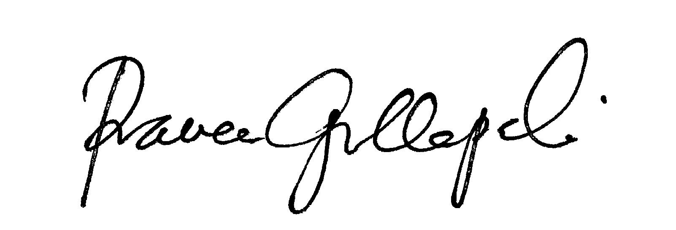 | 3/10/2021
Earl Simson | Dean of FAS | Earl Simson | 3/30/2021
 |  |  | Tab to add rows

D.2. Acknowledgements: REQUIRED from OTHER PROGRAMS/DEPARTMENTS (and their relevant deans if not already included above) that are IMPACTED BY THE PROPOSAL. SIGNATURE DOES NOT INDICATE APPROVAL, ONLY AWARENESS THAT THE PROPOSAL IS BEING SUBMITTED. CONCERNS SHOULD BE BROUGHT TO THE UCC COMMITTEE MEETING FOR DISCUSSION; all faculty are welcome to attend.
Name | Position/affiliation | Signature | Date
Mary Baker | Director of Environmental Studies | *approved via e-mail | 3/11/2021
Eliani Basile | Chair of Modern Languages | Eliani Basile | 3/19/2021
Moonsil Kim/April Kiser | Co-Director of Global Studies | *approved via e-mail | 3/11/2021
Robyn Linde | Director of INGOS | 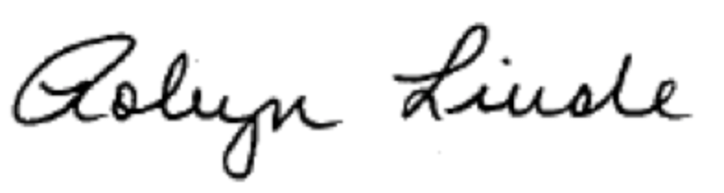 | 3/10/2021

