UNDERGRADUATE CURRICULUM COMMITTEE (UCC)
PROPOSAL FORM

Cover page scroll over blue text to see further important instructions: [if not working select “COMMents on rollover” in your Word preferences under view] please read these.
N.B. Please do not use highlight to select choices within a category but simply delete the options that do not apply to your proposal (e.g. in A.2 if this is a course revision proposal, just delete the creation and deletion options and the various program ones, so it reads “course revision”) Do not ever delete any of the numbered categories—if they do not apply leave them blank. ALL numbered categories in section (A) must be completed. If there are no resources impacted it is okay to put “none” in A. 7
A.1. Course or program | ANTH 460W Capstone Seminar in Anthropology
Replacing | ANTH 460W Seminar in Anthropology
A. 1b. Academic unit | Faculty of Arts and Sciences
A.2. Proposal type | Course: revision
A.3. Originator | Praveena Gullapalli | Home department | Anthropology
A.4. Context and Rationale  Note: Must include this additional information for all new programs | This is a proposal to revise the course title and description of ANTH 460W, the capstone experience in the Anthropology major. The new title and updated description more accurately reflect the content and nature of the course, both of which have been incrementally refined over time since the inception of the course. The addition of the term ‘Capstone’ highlights the fact that, in Anthropology, this is “a course that is the culminating experience for a program of study” (as described in the UCC manual’s Glossary of Terms). The description of the course has been modified to highlight the importance of the research process and project, and to emphasize bringing together the various strands of the major. We deleted the phrase “required of all majors” to be consistent with other capstone courses, as this is evident from the program requirements.
A.5. Student impact | The course description will better match the content and nature of the course.
A.6. Impact on other programs | None
A.7. Resource impact | Faculty PT & FT: | None
 | Library: | None
 | Technology | None
 | Facilities: | None
A.8. Semester effective | Fall 2021 | A.9. Rationale if sooner than next Fall
A.10. INSTRUCTIONS FOR CATALOG COPY: This single file copy must include ALL relevant pages from the college catalog, and show how the catalog will be revised. (1) Go to the “Forms and Information” page on the UCC website. Scroll down until you see the Word files for the current catalog. (2) Download ALL catalog sections relevant for this proposal, including course descriptions and/or other affected programs. (3) Place ALL relevant catalog copy into a single file. Put page breaks between sections and delete any catalog pages not relevant for this proposal. (4) Using the track changes function, revise the catalog pages to demonstrate what the information should look like in next year’s catalog. (5) Check the revised catalog pages against the proposal form, especially making sure that program totals are correct if adding/deleting course credits. If new copy, indicate where it should go in the catalog. If making related proposals a single catalog copy that includes all is preferred. Send catalog copy as a separate single Word file along with this form.
B. NEW OR REVISED COURSES Delete section B if the proposal does not include a new or revised course. As in section A. do not highlight but simply delete suggested options not being used. Always fill in b. 1 and B. 3 for context.
 | Old (for revisions only)  ONLY include information that is being revised, otherwise leave blank. | New  Examples are provided within some of the boxes for guidance, delete just the examples that do not apply.
B.1. Course prefix and number | ANTH 460W | ANTH 460W
B.2. Cross listing number if any
B.3. Course title | Seminar in Anthropology | Capstone Seminar in Anthropology
B.4. Course description | Anthropological concepts and theory are examined within a holistic framework. Students conduct research and complete a senior paper. Required of majors. This is a Writing in the Discipline (WID) course. | In this culminating experience for majors, students use anthropological methods to address original research questions by collecting, analyzing, and presenting anthropological data in a formal paper. This is a Writing in the Discipline (WID) course.
B.5. Prerequisite(s)
B.6. Offered
B.7. Contact hours
B.8. Credit hours
B.9. Justify differences if any
B.10. Grading system
B.11. Instructional methods
B.11.a Delivery Method
B.12.Categories
B.13. Is this an Honors course? | NO | NO
B.14. General Education  N.B. Connections must include at least 50% Standard Classroom instruction. | NO | NO
B.15. How will student performance be evaluated?
B.16 Recommended class-size
B.17. Redundancy statement
B. 18. Other changes, if any

B.19. Course learning outcomes: List each one in a separate row | Professional Org.Standard(s), if relevant | How will each outcome be measured?
 |  | Click Tab from here to add rows

B.20. Topical outline: DO NOT INSERT WHOLE SYLLABUS, JUST A TWO-TIER TOPIC OUTLINE. Proposals that ignore this request will be returned for revision.

D. Signatures
- Changes that affect General Education in any way MUST be approved by ALL Deans and COGE Chair.
- Changes that directly impact more than one department/program MUST have the signatures of all relevant department chairs, program directors, and their relevant dean (e.g. when creating/revising a program using courses from other departments/programs). Check UCC manual 4.2 for further guidelines on whether the signatures need to be approval or acknowledgement.
- Proposals that do not have appropriate approval signatures will not be considered.
- Type in name of person signing and their position/affiliation.
- Send electronic files of this proposal and accompanying catalog copy to curriculum@ric.edu and a printed signature copy of this whole form to the current Chair of UCC. Check UCC website for due dates.

D.1. Approvals: required from programs/departments/deans who originate the proposal. THESE may include multiple departments, e.g., for joint/interdisciplinary proposals.
Name | Position/affiliation | Signature | Date
Praveena Gullapalli | Chair of Anthropology | 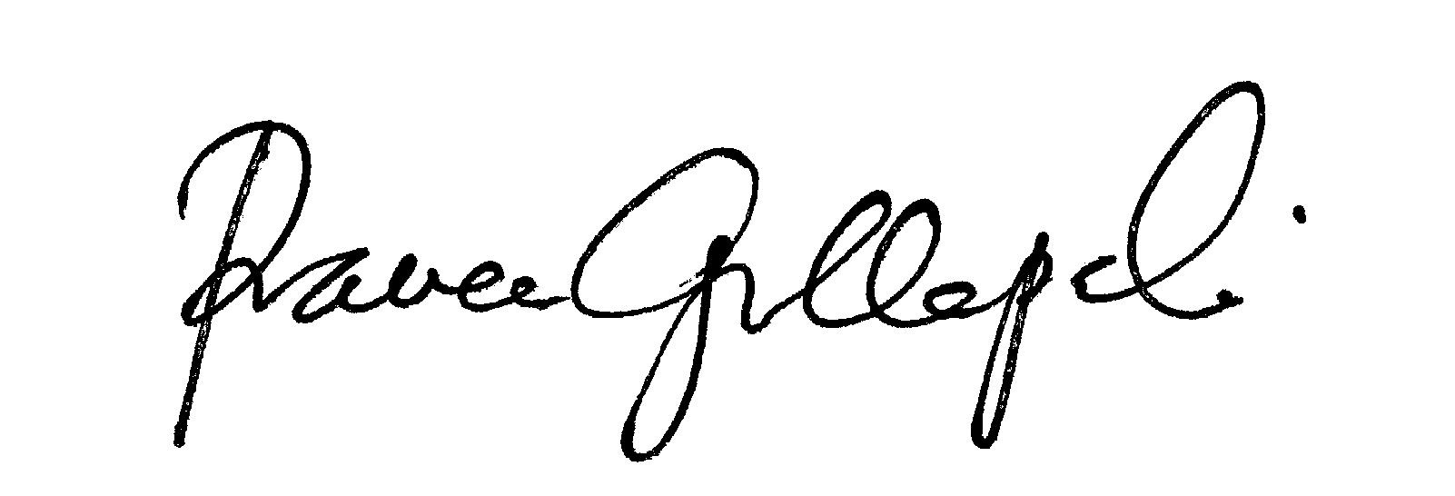 | 4 Mar 21
Earl Simson | Dean of FAS | Earl Simson | 3/30/2021
 |  |  | Tab to add rows

D.2. Acknowledgements: REQUIRED from OTHER PROGRAMS/DEPARTMENTS (and their relevant deans if not already included above) that are IMPACTED BY THE PROPOSAL. SIGNATURE DOES NOT INDICATE APPROVAL, ONLY AWARENESS THAT THE PROPOSAL IS BEING SUBMITTED. CONCERNS SHOULD BE BROUGHT TO THE UCC COMMITTEE MEETING FOR DISCUSSION; all faculty are welcome to attend.
Name | Position/affiliation | Signature | Date
 |  |  | Tab to add rows

