UNDERGRADUATE CURRICULUM COMMITTEE (UCC)
PROPOSAL FORM

Cover page scroll over blue text to see further important instructions: [if not working select “COMMents on rollover” in your Word preferences under view] please read these.
N.B. DO NOT USE HIGHLIGHT, where choices are given within categories, please DELETE those THAT DO NOT APPLY TO YOUR PROPOSAL. Do not delete numbered categories.
ALL numbers in section (A) to be completed, including the impact ones (#5-7), put “none” if that is the case.
A.1. Course or program | Writing in the Disciplines
Replacing
A.2. Proposal type | Course: | revision |
A.3. Originator | Mike Michaud | Home department | English/Writing Board
A.4. Context and Rationale | Last year a proposal was submitted to increase awareness at RIC about the Writing in the Discipline (WID) component of undergraduate programs at the college. All courses designated as WID were to have a “W” attached to their prefixes to make them more visible. Not all departments had completed their WID plans and so not all were included in that proposal. This proposal is to add these plans to the overall list and ensure these additional courses are given the “W” in the prefix.  To ensure that Records will be able to identify the course with a “W” at the end that works as prerequisite for other courses, those courses will need to have their prerequisites amended to say (for example), FREN 201 or FREN 201W. This will be done on the catalog copy to avoid confusion as it revises so many additional courses. We would ideally like to have these all in place within Records and in the Fall 2022 catalog.  Management and Marketing also decided to change their WID course selection, and those changes have been added to this form.  Additional Courses are:  CHEM 205 Organic Chemistry I  CHEM 206 Organic Chemistry II  CHEM 404 Analytical Chemistry  CHEM 407 Physical Chemistry Laboratory I  CHEM 416 Environmental Analytical Chemistry  ELED 202 Teaching All Learners: Foundations and Strategies  ENGL 230 Workplace Writing  ENGL 233 Writing for Health Professions  FREN 201 Advanced French: Conversation and Composition  FREN 202 Advanced French: Composition and Conversation  FREN 420 Applied Grammar  FREN 460 Seminar in French  GEOG 100 Introduction to Environmental Geography  GEOG 460 Senior Seminar: Theory and Research (done in course listings but not in program)  MGT 430 Strategic Human Resource Management  MGT 461 Seminar in Strategic Management  MUS 205 Music History and Literature I  MUS 206 Music History and Literature II  MUS 391 Junior Recital  MUS 492 Senior Recital  MUS 493 Senior Recital  PFA 461 Senior Seminar  PHYS 313 Junior Laboratory  PHYS 413 Senior Laboratory  PORT 201 Advanced Portuguese: Conversation and Composition  PORT 202 Advanced Portuguese: Composition and Conversation  PORT 420 Applied Grammar  PORT 460 Seminar in Portuguese  SWRK 302 Social Work Reseach Methods I  SWRK 326 Generalist Social Work Practice  SPAN 201 Conversation and Composition  SPAN 202 Composition and Conversation  SPAN 420 Applied Grammar  SPAN 460 Seminar in Spanish  SPED 202 Teaching All Learners: Foundations and Strategies  SPED 210 Supportiung Social, Emotional and Behavioral Learning  SPED 312 Assessment Procedures for Students with Special Needs  YDEV 300 Introduction to Youth Development  YDEV 352 Seminar in Youth Development  Deletion of “W” status:  GEOG 200 World Regional Geography  MGT 322 Organizational Behavior  MGT 348 Operations Management  MKT 215 Marketing Creativity  MKT 334 Consumer Behavior  SPED 436 Assessment/Instruction: Older Students with SID
A.5. Student impact | It is hoped that this initiative will raise awareness among students about when they are enrolled in a course that has been designated by their department/program as a Writing in the Disciplines (WID) course.
A.6. Impact on other programs | Because WID is a requirement of all undergraduate departments and programs on campus, this proposal impacts every unit that houses an undergraduate major—just the Deans have been asked to sign, but as part of the General Education program, this will also need approval from COGE.
A.7. Resource impact | Faculty PT & FT: | No impact. Only effects existing faculty.
 | Library: | None.
 | Technology | None.
 | Facilities: | None.
A.8. Semester effective | Fall 2021. | A.9. Rationale if sooner than next Fall
A.10. INSTRUCTIONS FOR CATALOG COPY: This single file copy must include ALL relevant pages from the college catalog, and show how the catalog will be revised. (1) Go to the “Forms and Information” page on the UCC website. Scroll down until you see the Word files for the current catalog. (2) Download ALL catalog sections relevant for this proposal, including course descriptions and/or other affected programs. (3) Place ALL relevant catalog copy into a single file. Put page breaks between sections and delete any catalog pages not relevant for this proposal. (4) Using the track changes function, revise the catalog pages to demonstrate what the information should look like in next year’s catalog. (5) Check the revised catalog pages against the proposal form, especially making sure that program totals are correct if adding/deleting course credits. If new copy, indicate where it should go in the catalog. If making related proposals a single catalog copy that includes all is acceptable. Send as a separate single file along with this form.

D. Signatures
- Changes that affect General Education in any way MUST be approved by ALL Deans and COGE Chair.
- Changes that directly impact more than one department/program MUST have the signatures of all relevant department chairs, program directors, and their relevant dean (e.g. when creating/revising a program using courses from other departments/programs). Check UCC manual 4.2 for further guidelines on whether the signatures need to be approval or acknowledgement.
- Proposals that do not have appropriate approval signatures will not be considered.
- Type in name of person signing and their position/affiliation.
- Send electronic files of this proposal and accompanying catalog copy to curriculum@ric.edu and a printed signature copy of this whole form to the current Chair of UCC. Check UCC website for due dates.

D.1. Approvals: required from programs/departments/deans who originate the proposal. may include multiple departments, e.g., for joint/interdisciplinary proposals.
Name | Position/affiliation | Signature | Date
Mike Michaud | Writing in the Disciplines Coordinator (Interim) | *Approved by e-mail | 3/1/2021
Earl Simson | Dean, Faculty of Arts and Sciences | Earl Simson | 3/5/2021
Alema Karim | Acting Dean of School of Business | Alema Karim | 3/5/2021
Jeannine Dingus-Eason | Dean of Feinstein School of Education and Human Development | Jeannine E. Dingus-Eason | 3/8/2021
Jayashree Nimmagadda | Interim Dean of School of Social Work (interim) |  | 3/6/2021
Carolynn Masters | Dean of Nursing | 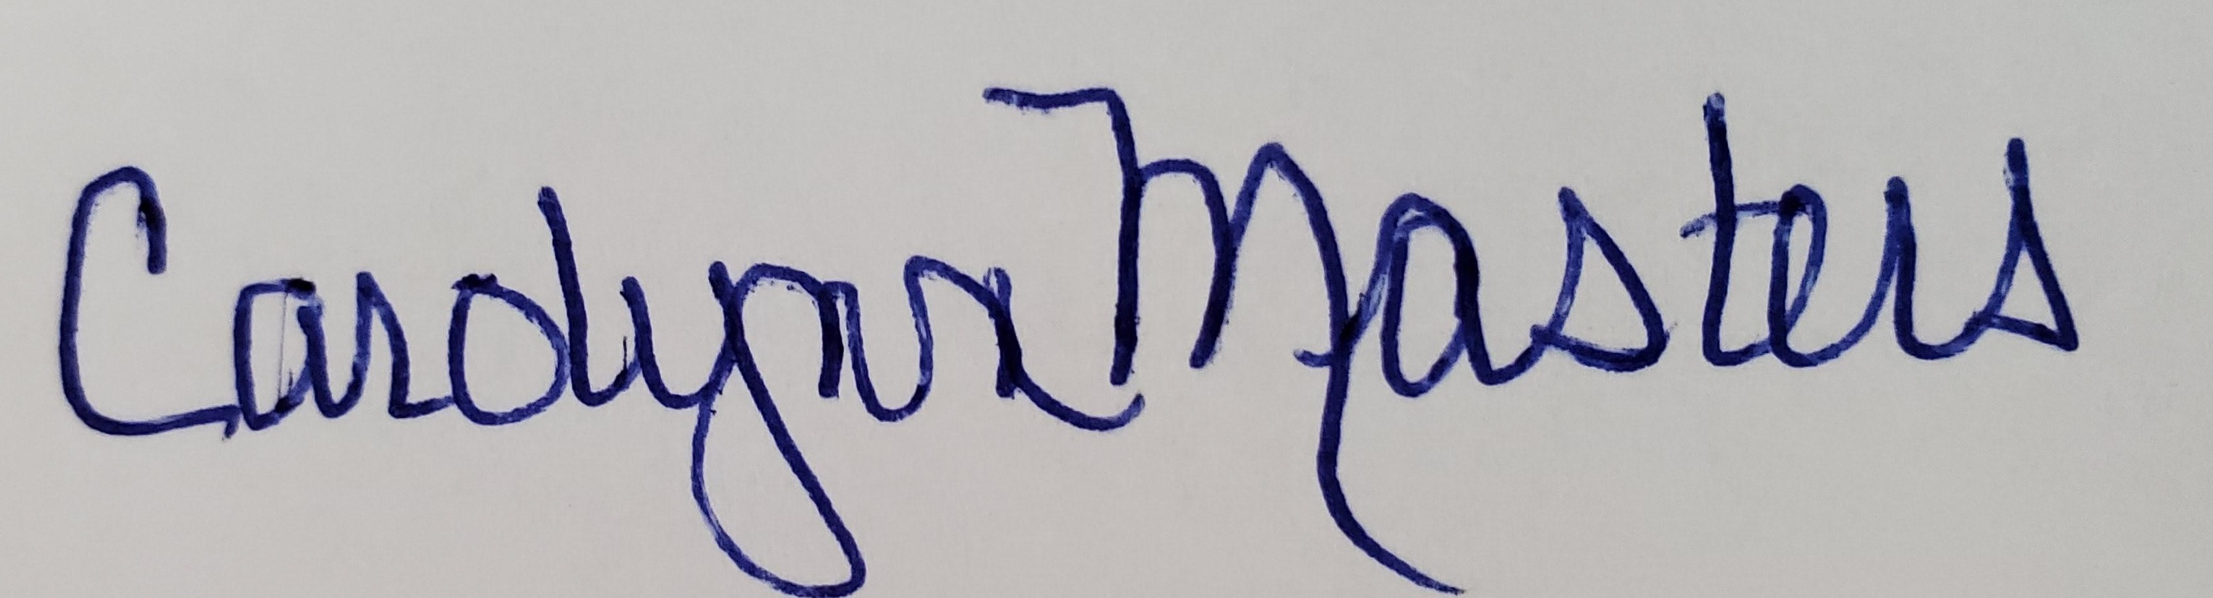 | 3/5/2021
Joseph Zornado | Chair of COGE | *Approved by e-mail | 3/5/2021

D.2. Acknowledgements: REQUIRED from OTHER PROGRAMS/DEPARTMENTS (and their relevant deans if not already included above) that are IMPACTED BY THE PROPOSAL. SIGNATURE DOES NOT INDICATE APPROVAL, ONLY AWARENESS THAT THE PROPOSAL IS BEING SUBMITTED. CONCERNS SHOULD BE BROUGHT TO THE UCC COMMITTEE MEETING FOR DISCUSSION; all faculty are welcome to attend.
Name | Position/affiliation | Signature | Date
 |  |  | Tab to add rows

