UNDERGRADUATE CURRICULUM COMMITTEE (UCC)
PROPOSAL FORM

Cover page scroll over blue text to see further important instructions: [if not working select “COMMents on rollover” in your Word preferences under view] please read these.
N.B. Please do not use highlight to select choices within a category but simply delete the options that do not apply to your proposal (e.g. in A.2 if this is a course revision proposal, just delete the creation and deletion options and the various program ones, so it reads “course revision”) Do not ever delete any of the numbered categories—if they do not apply leave them blank. ALL numbered categories in section (A) must be completed. If there are no resources impacted it is okay to put “none” in A. 7
A.1. Course or program | Minor in data science  CIS 470 Introduction to Data Science
Replacing
A. 1b. Academic unit | Faculty of Arts and Sciences
A.2. Proposal type | Program: revision (name change only)  AND  Course: revision (name change only)
A.3. Originator | Lisa Bain | Home department | Computer Science and Info Systems (CSIS)
A.4. Context and Rationale  Note: Must include this additional information for all new programs | Computer Science and Information Systems is a newly formed department in FAS that houses both Computer Science and Computer Information Systems programs. One of the minors on offer through Computer Information Systems was called the Data Science minor, and established in 2018. To ensure students do not get this confused with the more mathematically focused new Data Science major that was approved last year and that is housed in the Mathematical Sciences department, we would like to change our minor to Data Analytics, along with retitling CIS 470 Introduction to Data Analytics. Basically, data scientists build data programs, while analysts are trained to use them.  Also, the CSIS Department is developing a new Graduate Certificate in Data Analytics and will be using CIS 470 as part of that program. Changing the name will align the course with the new certificate.  Given that minors are listed in the catalog AFTER the majors, the whole minor has been moved to the end of the CIS department programs, and some redunancies on the CIS catalog page have been fixed, as well as the listing at the start of the FAS section where some minors were listed under “majors” in error.  Additional Information on Data Science versus Data Analytics  Both require similar skillsets but differ in their focus and job markets. The following information is provided by the Business-Higher Education Forum. Source: BHEF (2017, April). Investing in America’s data science and analytics talent. Retrieved from https://www.pwc.com/us/dsa-skills  Data scientists create sophisticated analytical models used to build new data sets and derive new insights from data. Data engineers design, build, and maintain an organization’s data and analytical infrastructure.* These require very strong skills in math and statistics.  Data analyst leverage data analysis and modeling techniques to solve problems and glean insight across functional domains. Functional analysts utilize data and analytical models to inform domain-specific functions and business decisions.* These require a strong understanding of math and statistics.  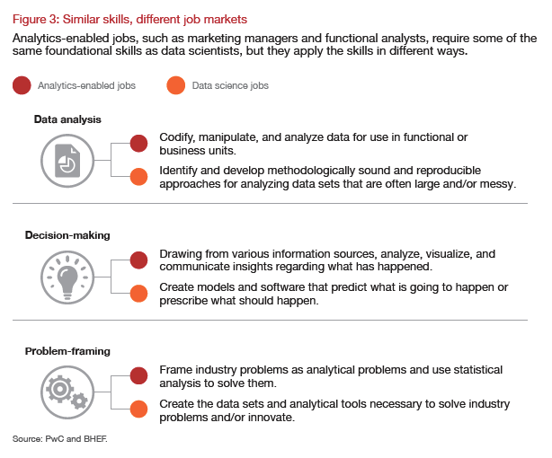  Currently, there is a shortage of job candidates with both data science and analytics skills and the demand is growing with new job postings estimated to reach 2.72M in 2020.
A.5. Student impact | Positive. We feel this name change will only broaden the appeal of the minor and course to additional majors at the college. There is a chance that the current students minoring in Data Science will not want the name change. However, the name will remain for these and only new minors added starting in Fall 2021 will use the new name.
A.6. Impact on other programs | None for the minor. Minimal for the course. CIS 470 is a required course in the B.S. in Data Science Program. However, the B.S. includes a course titled MATH 245 Principles in Data Science. The name change for CSI 470 will differentiate the courses.
A.7. Resource impact | Faculty PT & FT: | No impact on faculty since it is only a name change. This course is offered each fall. Existing CS and CIS faculty have the required skill sets to teach the course.
 | Library: | None.
 | Technology | None.
 | Facilities: | No additional needs. Course can be taught online, hybrid, or in-person using existing computer labs.
A.8. Semester effective | Fall 2021 | A.9. Rationale if sooner than next Fall
A.10. INSTRUCTIONS FOR CATALOG COPY: This single file copy must include ALL relevant pages from the college catalog, and show how the catalog will be revised. (1) Go to the “Forms and Information” page on the UCC website. Scroll down until you see the Word files for the current catalog. (2) Download ALL catalog sections relevant for this proposal, including course descriptions and/or other affected programs. (3) Place ALL relevant catalog copy into a single file. Put page breaks between sections and delete any catalog pages not relevant for this proposal. (4) Using the track changes function, revise the catalog pages to demonstrate what the information should look like in next year’s catalog. (5) Check the revised catalog pages against the proposal form, especially making sure that program totals are correct if adding/deleting course credits. If new copy, indicate where it should go in the catalog. If making related proposals a single catalog copy that includes all is preferred. Send catalog copy as a separate single Word file along with this form.

B. NEW OR REVISED COURSES Delete section B if the proposal does not include a new or revised course. As in section A. do not highlight but simply delete suggested options not being used. Always fill in b. 1 and B. 3 for context.
 | Old (for revisions only)  ONLY include information that is being revised, otherwise leave blank. |  |  | New  Examples are provided within some of the boxes for guidance, delete just the examples that do not apply.
B.1. Course prefix and number | CIS 470 |  |  | CIS 470
B.2. Cross listing number if any
B.3. Course title | Introduction to Data Science |  |  | Introduction to Data Analytics
B.4. Course description
B.5. Prerequisite(s)
B.6. Offered
B.7. Contact hours
B.8. Credit hours
B.9. Justify differences if any
B.10. Grading system
B.11. Instructional methods
B.11.a Delivery Method
B.12.Categories
B.13. Is this an Honors course?
B.14. General Education
N.B. Connections must include at least 50% Standard Classroom instruction.
B.15. How will student performance be evaluated?
B.16 Recommended class-size
B.17. Redundancy statement
B. 18. Other changes, if any

B.19. Course learning outcomes: List each one in a separate row | Professional Org.Standard(s), if relevant | How will each outcome be measured?

C. Program Proposals complete only what is relevant to your proposal if this is a revision, but include the enrollment numbers for all proposals. Delete section C if the proposal is not revising, creating, deleting or suspending any progam.
 | Old (for revisions only) | New/revised
C.1. Enrollments | Active dept majors (318)  CIS (88), CS-BS (94), CS-BA (136)  Active Data Science Minors (21)
C.2. Admission requirements
C.3. Retention requirements
C.4. Course requirements for each program option. Show the course requirements for the whole program here. | Minor in Data Science  MATH 177 or 212  MATH 240 or 248  CIS 252  CIS 301 or CSCI 157  CIS 470 Introduction to Data Science  CIS 472 Data Visualization | Minor in Data Analytics  MATH 177 or 212  MATH 240 or 248  CIS 252  CIS 301 or CSCI 157  CIS 470 Introduction to Data Analytics  CIS 472 Data Visualization
C.5. Credit count for each program option | Total Credit Hours: 24 | Total Credit Hours: 24
C.6. Program Accreditation (if relevant)
C.7. Other changes if any |  | Moved catalog placement to the end of the department’s programs, where minors are usually listed. And listed in correct section in the contents for FAS.
C.8. Program goals
Needed for all new programs

D. Signatures
- Changes that affect General Education in any way MUST be approved by ALL Deans and COGE Chair.
- Changes that directly impact more than one department/program MUST have the signatures of all relevant department chairs, program directors, and their relevant dean (e.g. when creating/revising a program using courses from other departments/programs). Check UCC manual 4.2 for further guidelines on whether the signatures need to be approval or acknowledgement.
- Proposals that do not have appropriate approval signatures will not be considered.
- Type in name of person signing and their position/affiliation.
- Send electronic files of this proposal and accompanying catalog copy to curriculum@ric.edu and a printed signature copy of this whole form to the current Chair of UCC. Check UCC website for due dates.

D.1. Approvals: required from programs/departments/deans who originate the proposal. THESE may include multiple departments, e.g., for joint/interdisciplinary proposals.
Name | Position/affiliation | Signature | Date
Lisa Bain | Chair, CSIS Dept | *Approved via email | 2/18/2021
Earl Simson | Dean, Faculty of Arts & Sciences | Earl Simson | 2/26/2021

D.2. Acknowledgements: REQUIRED from OTHER PROGRAMS/DEPARTMENTS (and their relevant deans if not already included above) that are IMPACTED BY THE PROPOSAL. SIGNATURE DOES NOT INDICATE APPROVAL, ONLY AWARENESS THAT THE PROPOSAL IS BEING SUBMITTED. CONCERNS SHOULD BE BROUGHT TO THE UCC COMMITTEE MEETING FOR DISCUSSION; all faculty are welcome to attend.
Name | Position/affiliation | Signature | Date
Rebecca Sparks | Chair, Mathematical Sciences Dept | *Approved via email | 2/23/2021

