UNDERGRADUATE CURRICULUM COMMITTEE (UCC)
PROPOSAL FORM

Cover page scroll over blue text to see further important instructions: [if not working select “COMMents on rollover” in your Word preferences under view] please read these.
N.B. Please do not use highlight to select choices within a category but simply delete the options that do not apply to your proposal (e.g. in A.2 if this is a course revision proposal, just delete the creation and deletion options and the various program ones, so it reads “course revision”) Do not ever delete any of the numbered categories—if they do not apply leave them blank. ALL numbered categories in section (A) must be completed. If there are no resources impacted it is okay to put “none” in A. 7
A.1. Course or program | (deletions) CURR 347; GRMN 113; GRMN 114; HPE 151; HPE 208; HPE 251; HPE 302; HPE 351; HIST 326; HSCI 102; NURS 312; PHIL 201; PHIL 300; (revisions) HPE 207; YDEV 353
Replacing
A. 1b. Academic unit | Faculty of Arts and Sciences | School of Education | School of Nursing
A.2. Proposal type | Course: | deletion and revision  Program: revision |
A.3. Originator | Susan Abbotson | Home department | Chair of UCC
A.4. Context and Rationale  Note: Must include this additional information for all new programs | The following courses can be deleted as they have not been offered in three or more years and/or the departments who have offered them in the past see no need to keep them in the catalog: CURR 347 Service Learn in Educational Contexts (and also drop the reference to this in the YDEV 353 Field Experience in Youth Development description); GRMN 113 Intermediate German; GRMN 114 Readings in Intermediate German; HPE 151 Introduction to Recreation in Modern Society, HPE 208 Motor Skill Development for Lifetime Wellness II (which also means that HPE 207 Motor Skill Development for Lifetime Wellness I, should drop the roman numeral) ; HPE 251 Recreation Delivery Systems; HPE 302 Practicum in Team Activities; HPE 351 Leadership and Supervision of Recreation; HSCI 102 Food Plant Sanitation; HIST 326 American Cultural History: Nineteenth Century; NURS 312 Death and Dying; PHIL 201 Introduction to Eastern Philosophy; and PHIL 300 American Philosophy. We are also taking the opportunity to have the catalog list the GRTL 314/NURS 314 more cleanly.
A.5. Student impact | None of these are absolutely required, so this will have no real effect, just a few less electives in some programs, while cleaning up the catalog and keeping it current.
A.6. Impact on other programs | Gerontology minor and the Community and Public Health Promotion concentration in Health and Aging—will lose NURS 312 as one of their required electives (though they still have other choices). This will also alter the total count for Gerontology to 22-26 from 21-26 (as only one of the remaining electives is 3 credits), but has no effect on Health and Aging. The Wellness and Exercise Science BS program will lose one elective but has no affect on the total count. PHIL 201 and 300 will need to be deleted as electives from the Philosophy Minor in the History of Philsophical Thought, again, this will not affect total counts. GRMN 114 was an EEP course, but that is no longer offered in the area schools, so no longer needs to be in the catalog.
A.7. Resource impact | Faculty PT & FT: | None
 | Library: | None
 | Technology | None
 | Facilities: | None
A.8. Semester effective | Fall 2021 | A.9. Rationale if sooner than next Fall

D. Signatures
- Changes that affect General Education in any way MUST be approved by ALL Deans and COGE Chair.
- Changes that directly impact more than one department/program MUST have the signatures of all relevant department chairs, program directors, and their relevant dean (e.g. when creating/revising a program using courses from other departments/programs). Check UCC manual 4.2 for further guidelines on whether the signatures need to be approval or acknowledgement.
- Proposals that do not have appropriate approval signatures will not be considered.
- Type in name of person signing and their position/affiliation.
- Send electronic files of this proposal and accompanying catalog copy to curriculum@ric.edu and a printed signature copy of this whole form to the current Chair of UCC. Check UCC website for due dates.

D.1. Approvals: required from programs/departments/deans who originate the proposal. THESE may include multiple departments, e.g., for joint/interdisciplinary proposals.
Name | Position/affiliation | Signature | Date
Desirée Ciambrone | Program Director of Gerontology | Desirée Ciambrone | 1/30/2021
Jason Sawyer | Program Director Wellness and Exercise Science | Jason Sawyer | 2/2/2021
Carol Cummings | Chair of CPHP | *Approved via e-mail | 2/10/2021
Carolynn Masters | Dean of SON | 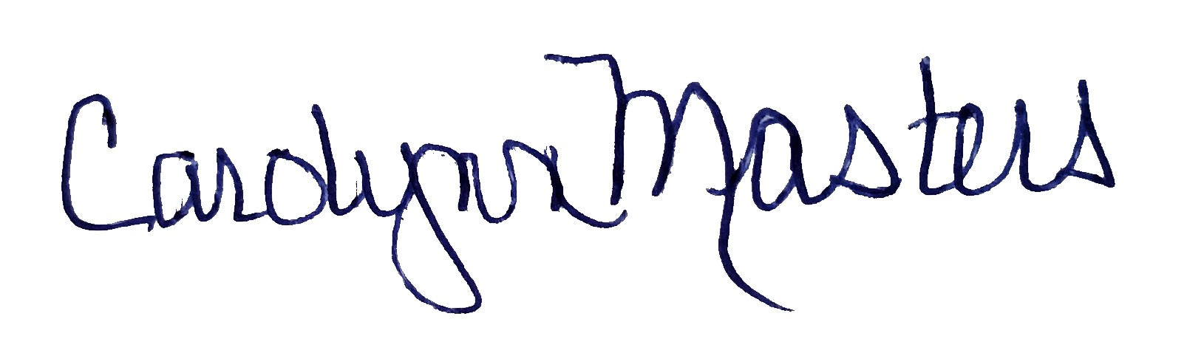 | 2/11/2021
Jeannine Dingus-Eason | Dean of FSHED | *Approved via e-mail | 2/9/2021
Lesley Bogad | Educational Studies (for CURR) | *Approved via e-mail | 2/11/2021
Eliani Basile | Modern Languages | *Approved via e-mail | 2/8/2021
Elisa Miller | History | *Approved via e-mail | 1/31/2021
Eric Hall | Program Director of HSCI |  | 1/29/2021
Aaron Smuts | Philosophy | *Approved via e-mail | 2/11/2021
Earl Simson | Dean FAS | 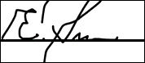 | 2/8/2021

D.2. Acknowledgements: REQUIRED from OTHER PROGRAMS/DEPARTMENTS (and their relevant deans if not already included above) that are IMPACTED BY THE PROPOSAL. SIGNATURE DOES NOT INDICATE APPROVAL, ONLY AWARENESS THAT THE PROPOSAL IS BEING SUBMITTED. CONCERNS SHOULD BE BROUGHT TO THE UCC COMMITTEE MEETING FOR DISCUSSION; all faculty are welcome to attend.
Name | Position/affiliation | Signature | Date

