UNDERGRADUATE CURRICULUM COMMITTEE (UCC)
PROPOSAL FORM

Cover page scroll over blue text to see further important instructions: [if not working select “COMMents on rollover” in your Word preferences under view] please read these.
N.B. DO NOT USE HIGHLIGHT, where choices are given within categories, please DELETE those THAT DO NOT APPLY TO YOUR PROPOSAL. Do not delete numbered categories.
ALL numbers in section (A) to be completed, including the impact ones (#5-7), put “none” if that is the case.
A.1. Course or program | anth 338: Urban anthropology
Replacing
A.2. Proposal type | Course: revision
A.3. Originator | Praveena Gullapalli | Home department | Anthropology
A.4. Context and Rationale | The current description and version of Urban Anthropology is an outdated, cross-cultural approach to that area of study that no longer reflects the current state of urban anthropology or anthropology in general. This revision brings the course into line with current approaches in urban anthropology and anthropology more generally. We are also adding an additional appropriate option as a prerequisite to open the course up to more students.
A.5. Student impact | Students will be exposed to more current approaches to urban anthropology; beyond that no impacts.
A.6. Impact on other programs | The course is an option in both the Global Studies and Environmental Studies programs.
A.7. Resource impact | Faculty PT & FT: | None.
 | Library: | None.
 | Technology | None.
 | Facilities: | None.
A.8. Semester effective | Fall 2020 | A.9. Rationale if sooner than next Fall
A.10. INSTRUCTIONS FOR CATALOG COPY: This single file copy must include ALL relevant pages from the college catalog, and show how the catalog will be revised. (1) Go to the “Forms and Information” page on the UCC website. Scroll down until you see the Word files for the current catalog. (2) Download ALL catalog sections relevant for this proposal, including course descriptions and/or other affected programs. (3) Place ALL relevant catalog copy into a single file. Put page breaks between sections and delete any catalog pages not relevant for this proposal. (4) Using the track changes function, revise the catalog pages to demonstrate what the information should look like in next year’s catalog. (5) Check the revised catalog pages against the proposal form, especially making sure that program totals are correct if adding/deleting course credits. If new copy, indicate where it should go in the catalog. If making related proposals a single catalog copy that includes all is acceptable. Send as a separate single file along with this form.

B. NEW OR REVISED COURSES DO NOT use highlight. Do not delete numbered categories, just leave blank if they do not apply. Delete this whole page if the proposal does not include a new or revised course. Always fill in b. 1 and B. 3 for context.
 | Old (for revisions only)  ONLY include information that is being revised, otherwise leave blank. | New  Examples are provided within some of the boxes for guidance, delete just the examples that do not apply.
B.1. Course prefix and number | ANTH 338 | ANTH 338
B.2. Cross listing number if any
B.3. Course title | Urban Anthropology | Urban Anthropology
B.4. Course description | Western and non-Western traditions in urbanization are compared and contrasted. Cross-cultural comparisons are emphasized. | Students learn about the origins and characteristics of urban life. Ancient, historic, and contemporary urban phenomena in local and global contexts are explored, using archaeological, historical, and ethnographic methods.
B.5. Prerequisite(s) | ANTH 101 or consent of department chair | ANTH 101 or ANTH 102 or consent of department chair
B.6. Offered | Alternate Years | Alternate Years
B.7. Contact hours | 4 | 4
B.8. Credit hours | 4 | 4
B.9. Justify differences if any
B.10. Grading system | Letter grade | Letter grade
B.11. Instructional methods | | Lecture | Fieldwork | Lecture | Seminar | Small group |
B.12.Categories | Free elective | Free elective
B.13. Is this an Honors course? | NO | NO
B.14. General Education  N.B. Connections must include at least 50% Standard Classroom instruction. | NO | | NO |
B.15. How will student performance be evaluated? | Attendance | Class participation | Exams | Presentations | Papers |  Class Work |  Projects | | Attendance | Class participation | Exams | Presentations | Papers |  Class Work | Projects |
B.16 Recommended class-size |  | 30
B.17. Redundancy statement | N/A | N/A
B. 18. Other changes, if any

B.19. Course learning outcomes: List each one in a separate row | Professional Org.Standard(s), if relevant | How will each outcome be measured?
Students will demonstrate a basic understanding of the origins and characteristics of urban life. | N/A | See B.15
Students will demonstrate an understanding of how the built environment shapes and is shaped by social and cultural practice | N/A | See B.15
Students will demonstrate an understanding of the variation of human experience within and between cities | N/A | See B.15

B.20. Topical outline: DO NOT INSERT WHOLE SYLLABUS, JUST A TWO-TIER TOPIC OUTLINE. Proposals that ignore this request will be returned for revision.
Sample readings (articles and chapters/excerpts from):

Atkin, Tony and Joseph Rykwert, eds. 2005. Structure and Meaning in Human Settlement. University of Pennsylvania Museum of Archaeology and Anthropology
Blanton, Richard E. 1976. Anthropological studies of cities. Annual Review of Anthropology 5 (October): 249–264.
Brettell, Caroline. 2000. Urban history, urban anthropology, and the study of migrants in cities. City & Society 12.2 (December): 129–138.
Couture, Daisy, Matt Hern, Selena Couture, Sadie Couture, Denise Ferreira da Silva, and Glen S. Coulthard. 2018. On this patch of Grass: City Parks on Occupied Land. Fernwood Publishing.
De Certeau, Michel (Steven Rendell, trans). 1980. The Practice of Everyday Life. UC Press.
Hannerz, Ulf. 1980. Exploring the City: Inquiries Toward an Urban Anthropology. Columbia University Press.
Harvey, David. 2012. Rebel Cities: From the Right to the City to the Urban Revolution. Verso.
Jacobs, Jane. 1961. Death and Life of Great American Cities. Random House.
Jaffe, Rivke and Anouk De Koning. 2015. Introducing Urban Anthropology. Routledge.
Krase, Jerome and Zdeněk Uherek, eds. 2017. Diversity and Local Contexts: Urban Space, Borders, and Migration. Palgrave Studies in Urban Anthropology.
Kuldova, Tereza, and Mathew Varghese, eds. 2017. Urban Utopias: Excess and Expulsion in Neoliberal South Asia. Palgrave Studies in Urban Anthropology.
Low, Setha M., ed. 1999. Theorizing the City: The New Urban Anthropology Reader. Rutgers University Press.
Low, Setha and Neil Smith. 2013. The politics of public space. Routledge.
Nonini, Donald M., ed. 2014. A Companion to Urban Anthropology. John Wiley & Sons Ltd.
Sanjek, Roger, ed. 1994. Cities, Classes and The Social Order. Cornell Univ. Press.
Storey, Glenn R., ed. 2006. Urbanism in the Preindustrial World: Cross Cultural Approaches. U. Alabama Press.

Sample Topics:

1. Origins of urban life
a. The urban revolution
b. Characteristics of urbanism
2. Ancient cities
a. Variation in the urban form
b. What makes a city a city?
c. Cities and the emergence of inequality
3. Historic cities
a. Medieval and Early Modern contexts
b. Colonial cities, colonized cities
c. Epidemics, disease and population dynamics
4. Spaces and Places in the City
a. Neighborhoods
b. The planned city
c. Parks and green spaces
d. Marginal spaces and marginalized people
4. Power and Inequality
a. Capitalism and the neo-liberal city
b. Race and ethnicity
5. Communities and Place-making
a. Policies of inclusion and exclusion
b. Immigrant enclaves
6. Infrastructures and Industry
a. Industrial cities, industrial archaeology
b. Waste production and waste disposal
c. Roads and highways
7. Globalization
a. Global elite and the globalized city
b. Remaking and remapping connections
c. Transnational connections
d. Port cities
8. Urban experiences, urban ethnographies
a. The city as ethnographic/archaeological field site
9. Migrations and Cities
a. Rural – urban migrations
b. Cities and their hinterlands
10. Urban crucibles
a. Creativity and/in the city
b. Protest and Resistance
11. Historic preservation
a. Politics and policies of preservation
12. Urban ecosystems
a. Flora and fauna in the city
b. Cities as drivers/loci of evolution

D. Signatures
- Changes that affect General Education in any way MUST be approved by ALL Deans and COGE Chair.
- Changes that directly impact more than one department/program MUST have the signatures of all relevant department chairs, program directors, and their relevant dean (e.g. when creating/revising a program using courses from other departments/programs). Check UCC manual 4.2 for further guidelines on whether the signatures need to be approval or acknowledgement.
- Proposals that do not have appropriate approval signatures will not be considered.
- Type in name of person signing and their position/affiliation.
- Send electronic files of this proposal and accompanying catalog copy to curriculum@ric.edu and a printed signature copy of this whole form to the current Chair of UCC. Check UCC website for due dates.

D.1. Approvals: required from programs/departments/deans who originate the proposal. may include multiple departments, e.g., for joint/interdisciplinary proposals.
Name | Position/affiliation | Signature | Date
Praveena Gullapalli | Chair of Anthropology | 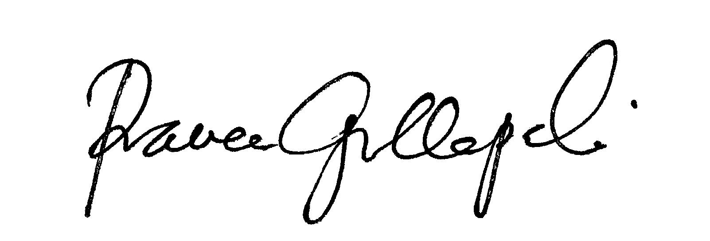 | 26 April 2020
Earl Simson | Dean, Faculty of Arts and Sciences | Earl Simson | 04/26/2020

D.2. Acknowledgements: REQUIRED from OTHER PROGRAMS/DEPARTMENTS (and their relevant deans if not already included above) that are IMPACTED BY THE PROPOSAL. SIGNATURE DOES NOT INDICATE APPROVAL, ONLY AWARENESS THAT THE PROPOSAL IS BEING SUBMITTED. CONCERNS SHOULD BE BROUGHT TO THE UCC COMMITTEE MEETING FOR DISCUSSION; all faculty are welcome to attend.
Name | Position/affiliation | Signature | Date
Mary Baker | Program Director of Environmental Studies | 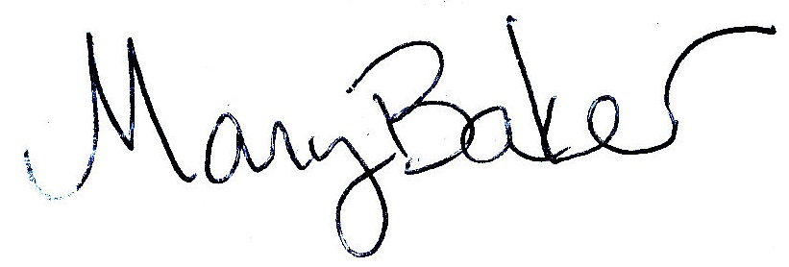 | 26 April 2020
Moonsil Kim | Co-Program Director of Global Studies | MoonsilLee | 27 April 2020

