UNDERGRADUATE CURRICULUM COMMITTEE (UCC)
PROPOSAL FORM

Cover page roll over blue text to see further important instructions: please read.
N.B. DO NOT USE HIGHLIGHT, JUST DELETE THE WORDS THAT DO NOT APPLY TO YOUR PROPOSAL
ALL numbers in section (A) need to be completed, including the impact ones.
A.1. Course or program | NURS 207 – Baccalaureate Education For Nursing
Replacing
A.2. Proposal type | Course: revision
A.3. Originator | Donna Huntley-Newby | Home department | School of Nursing
A.4. Rationale | The purpose of this revision is to clarify the pre-requisites for NURS 207
A.5. Date submitted | 4/10/2017 | A.6. Semester effective |  | Fall 2018
A.7. Resource impact | Faculty PT & FT: | NA
 | Library: | NA
 | Technology | NA
 | Facilities: | NA
A.8. Program impact | Clarify pre-requisites for progression
A.9. Student impact | Clarify pre-requisites for progression
A.10. The following screen tips are for information on what to do about catalog copy until the new CMS is in place; check the “Forms and Information” page for updates. Catalog page. Where are the catalog pages? Several related proposals? Do not list catalog pages here. All catalog copy for a proposal must be contained within a single file; put page breaks between sections. Make sure affected program totals are correct if adding/deleting course credits.

B. NEW OR REVISED COURSES DELETE THE WORDS THAT DO NOT APPLY TO YOUR PROPOSAL within specific categories, but do not delete any of the categories. DO NOT use highlight. Delete this whole page if this proposal does not include a new or revised course.
 | Old (for revisions only) | New
B.1. Course prefix and number | NURS 207 | same
B.2. Cross listing number if any
B.3. Course title
B.4. Course description
B.5. Prerequisite(s) | Licensed RN students | Licensed RN students and Nursing RN BSN IM, or consent of program director
B.6. Offered
B.7. Contact hours
B.8. Credit hours
B.9. Justify differences if any
B.10. Grading system
B.11. Instructional methods
B.12.Categories
B.13. Is this an Honors course? | | NO
B.14. General Education  N.B. Connections must include at least 50% Standard Classroom instruction. | | NO |  category:
B.15. How will student performance be evaluated?
B.16. Redundancy statement
B. 17. Other changes, if any

B.18. Course learning outcomes | Standard(s) | How will they be measured?
 |  | Click Tab from here to add rows

B.19. Topical outline
- Sample
  - Sample
  - Sample
- Sample
  - Sample etc.

D. Signatures

D.1. Approvals
- Changes that affect General Education in any way MUST be approved by ALL Deans and COGE Chair.
- Changes that directly impact more than one department/program MUST have the signatures of all relevant department chairs, program directors, and relevant dean (e.g. when creating/revising a program using courses from other departments/programs). Check UCC manual 4.2 for further guidelines on whether the signatures need to be approval or acknowledgement.
- Proposals that do not have appropriate approval signatures will not be considered.
- Type in name of person signing and their position/affiliation.
- Send electronic files of this proposal and accompanying catalog copy to curriculum@ric.edu and a printed or electronic signature copy of this form to the current Chair of UCC. Check UCC website for due dates.
Name | Position/affiliation | Signature | Date
Yolande Lockett | Chair of BSN Nursing
Jane Williams | Dean of School of Nursing
Donna Huntley-Newby | Director RN-BSN Program | 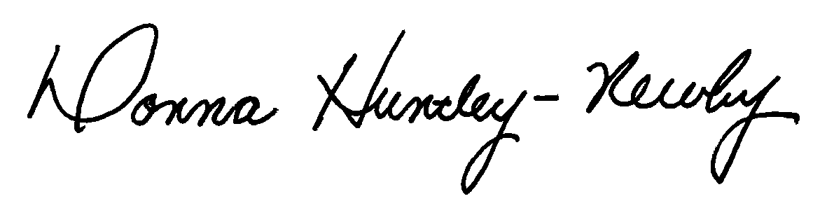 | 4/10/17

D.2. Acknowledgements
Name | Position/affiliation | Signature | Date
 |  |  | Tab to add rows

